**MSDS 6371 Group Project - D&B All-Stars**

Vanessa Torres

Michael Landrum

Travis Deason

Brian Coari

# Introduction

Introduction to the paper

# Data Description

(Where did the data come from? How big is it? How many observations? Where can we find out more? What are the specific variables that we need to know with respect to your analysis?)

# Analysis Question 1

Mr. Mason,

Thank you for contacting DABAS LLC; we feel confident we can answer your questions about the Ames, Iowa housing market. We were able to track down the most recent 2,930 home sales in Ames as well as 79 characteristics of each house. Since you are only interested in three specific neighborhoods, North Ames (NA), Eastwood (EW) and Brookside (BS), and how square footage (SF) relates to their sale price (SP, in dollars), we will restrict our model to only focus on those variables.

By examining the scatterplot (see Appendix Plot 1A), we concluded we would need to take the log of the sales price and square footage to create a linear relationship. Also, the slope of the regression lines of different neighborhoods would be different, so we included interaction terms. This means our model would look like this:

ln(SP) = B0 + B1 * ln(SF) + B2 * BS + B3 * EW + B4 * NA + B5 * ln(SF) * BS + B6 * ln(SF) * EW + B7 * ln(SF) * NA

To test our model, we used a null hypothesis that all Bi are zero, or that there is no correlation between sales price and any of the other variables. And our alternative hypothesis is that at least one Bi is not zero, or that there is a correlation between at least one of the variables and sales price. We received a p-value well below 0.05 (it actually was below 0.001, see Appendix Table 1B column 6), so we rejected the null hypothesis and concluded there was a relationship between the sales price and the other variables.

We then needed to test whether each individual variable was needed in our model. For each variable, our null hypothesis was that given the other variables contribution to the model, that particular variable did not help our model (or that the coefficient in front of that variable was 0). And our alternative hypothesis was that the variable contributed to the model (or that the coefficient in front of the variable was not 0). For each variable aside from BS, including the interaction terms, we received p-value below 0.05 (see Appendix Table 1C column 6), which means for each variable we rejected the null hypothesis and concluded that they were all beneficial to our model. Since the interaction term was significant that included BS, we kept BS in the model. The full regression equation is:

**ln(SP) = 5.16 + 0.95 ln(SF) + 1.04 BS + 2.40 EW + 3.33 NA – 0.17 BS ln(SF) - 0.36 EW ln(SF) - 0.48 NA ln(SF)**

Note: A zero for all categorical variables (BS, EW, NA) would represent the houses outside those three neighborhoods, but still in Ames. We decided to use them in an effort to reduce the overall variance to our model.

This model has an r-squared of 0.5649 and an adjusted r-squared of 0.5368. The r-squared means 56.49% of the variation in sales price, can be explained the variation in neighborhood and square footage. As always, these coefficients are just estimates. For instance, we are 95% confident the true coefficient for ln(Square Footage) is in the interval (0.914,0.984) (see Appendix 1C, row 3 columns 7 and 8. The other confidence intervals for the rest of the coefficients can be found in the same table.).

For us to use this model, we had to assume independence even though that likely isn't completely true. Also, this model gave us relatively normal residuals (slightly curved and skewed left, but with 2000+ observations, the Central Limit Theorem should kick in), but it did show some outliers and leverage points (see Appendix Plot 1D). We concluded the outliers were all accurate measurements so we had to include them. The model created after removing the leverage point gave very similar results to our model, so we decided to keep our model and include the leverage points **(**all confidence intervals for the coefficients contain the coefficients from our full model. See Appendix Table 1E).

We can simplify this model a little by separating it by neighborhood. This leaves us with three different equations you can look at depending on which neighborhood you are working with.

**{ ln(SP) | Brookside } = 6.20 + 0.78 ln(SF)**

**{ ln(SP) | Edwards } = 7.56 + 0.59 ln(SF)**

**{ ln(SP) | North Ames } = 8.49 + 0.47 ln(SF)**

In general, when you double the size of a house in Brookside, the sale price increases by a factor of 2.16. When you double the size of a house in Edwards, the sale price increases by a factor of 1.79. And when you double the size of a house in North Ames, the sale price increases by a factor of 1.56.

Note: The model created by removing the other neighborhoods produced the same regression equations for the individual neighborhoods (See Appendix Table 1F and Reference 1G).

Due to the nature of this study (it was an observational study by nature), we cannot infer causation and say the square footage or the neighborhood causes a change in the sales price of the house; there are obviously many confounding variables that play a part. But, we can say there is a correlation between the sales price and the square footage and neighborhood.

# Analysis Question 2

**Restatement of Problem**

**Overall Data Observations:**

* Number of Observations Read: 1460
* Number of Observations with Missing Values: 339
* Number of Observations Used: 1121

**Checking Assumptions:**

First we will look at the distribution of our response variable, the Sale Price using all of our identified continuous and indicator variables through proc reg.

***(****All plots for the SalePrice are available in the Appendix. Please see Appendix Table 2A).*

In the SalePrice plot group we see a few worrying things. The residual plot seems clustered tightly together with a few outliers.

1. **Normality**: Judging from the qq plot, there seems to be a curvature at the tail ends of the data, which violates normality.
2. **Constant variance:** Judging from the scatter plots we do not see a large concern with variance. There are many outliers that are concerning, but with so many observations that itself wouldn’t be out of the question… still, given the violation in normality we should try a transform and hope this gets better.
3. **Linear trend:** From the predicted value line and an adjusted R-Square of .91 our linear trend looks good here, so we will compare this to our transformed data.
4. We will assume all observations are **independent**.

***(****All plots for the scatterplots for the individual variables are available in the Appendix. Please see Appendix Table 2B).*

Viewing the scatterplots for the individual variables we see many variables with uneven distributions and distant outliers. These data points might also benefit from a log transformation

After taking the logs we see a few improvements in the model:

***(****All plots for the scatterplots for the SalePrice and the individual variables after the log transformations are available in the Appendix. Please see Appendix Tables 2C and 2D).*

After the transformations we see many improvements in the shape of our data. In general the data has become less affected by outliers, and closer to a random cloud.

1. **Normality**: Judging from the qq plot, the curvature at both ends is still present, but far less pronounced. The tails are mostly going to be formed by our large number of categorical variables that have a small number of discrete values. In the middle we see a straight line indicating normality, and the histogram shows a much more normal distribution.
2. **Constant variance:** Across the board the scatter plots are showing data that are more cloud-like and normal in their variance. We still have a large number of variables with values of zero which negatively affects our constant variance, but we do not see a way around this, we will accept it and proceed.
3. **Linear trend:** From the predicted value line we see a slight improvement here, which is also reflected by an increase in our adjusted R-Square to .93. Our linear trend looks even better than before the transformation.
4. We will assume all observations are **independent**.

**Comparing Competing Models**

**Forward**

***(****The Table output of the Forward Selection process is available in the Appendix. Please see Appendix Table 2E).*

**Backward**

***(****The Table output of the Backward Selection process is available in the Appendix. Please see Appendix Table 2F).*

**Stepwise**

***(****The Table output of the Stepwise Selection process is available in the Appendix. Please see Appendix Table 2G).*

**CUSTOM**

***(****The Table output of the Stepwise Selection process is available in the Appendix. Please see Appendix Table 2H).*

For our Custom model we decided to switch to a Significance-Level elimination and re-run against all three methods.

**Conclusion**:

|  |  |  |  |
| --- | --- | --- | --- |
| **Predictive Models** | Adjusted R2 | CV PRESS | Kaggle Score |
| Forward | 0.8488 | 27.26 |  |
| Backward | 0.9342 | 54.25 |  |
| Stepwise | 0.8488 | 27.26 |  |
| CUSTOM | 0.9372 | 17.72 |  |

A short summary of the analysis.

# Appendix

Plot 1A:

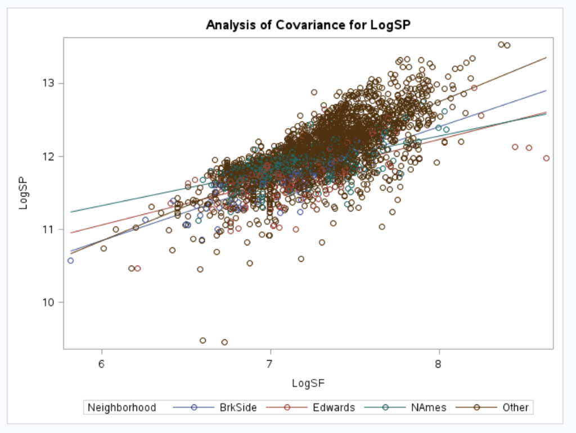

Table 1B:

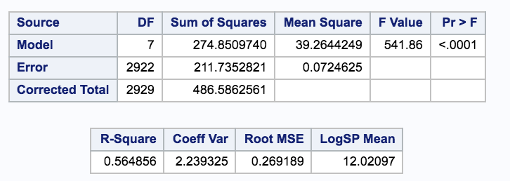

Table 1C:

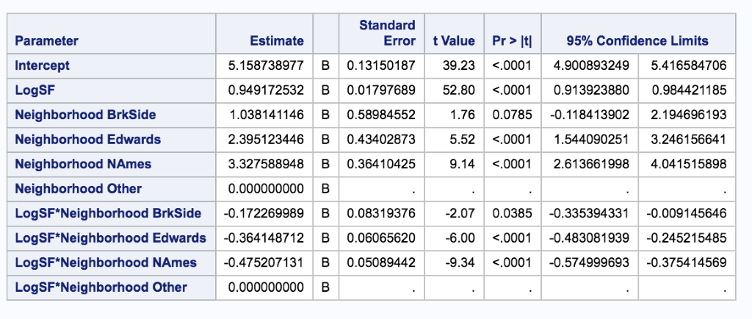

Plot 1D:

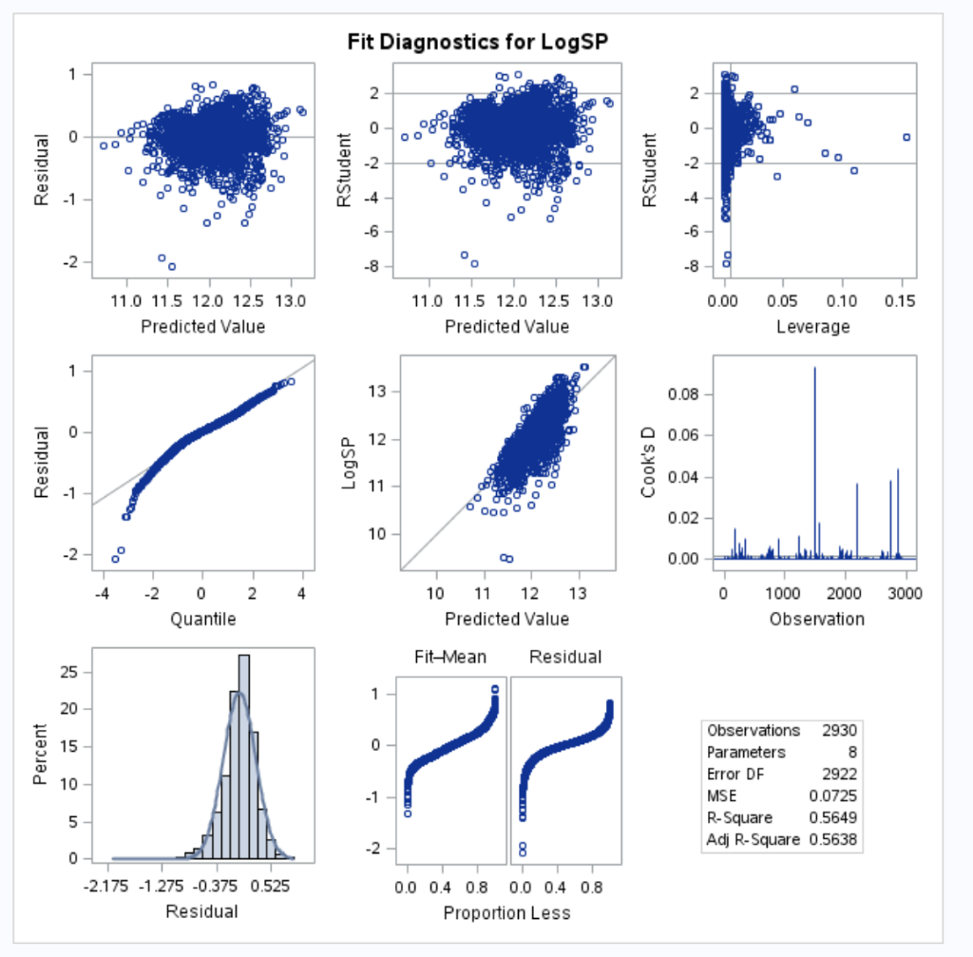

Table 1E:

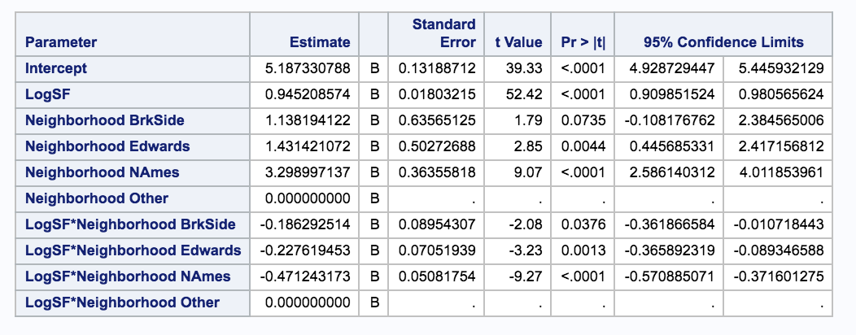

Table 1F:

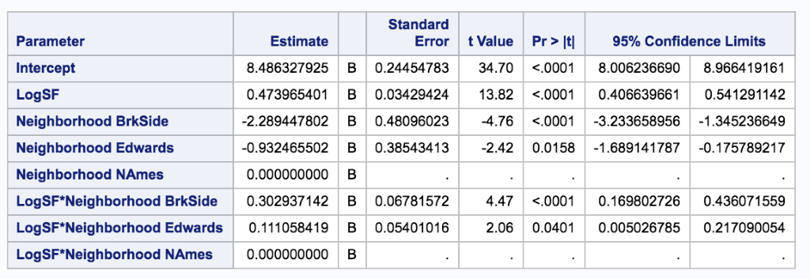

Reference 1G:

Separated regression equations:

{ ln(SP) | Brookside } = 6.19 + 0.77 ln(SF)

{ ln(SP) | Edwards } = 7.55 + 0.58 ln(SF)

{ ln(SP) | North Ames } = 8.48 + 0.47 ln(SF)

**Question 1 Code:**

R code to turn all other neighborhoods into "other", removed unwanted variables to help with speed of SAS and created log variables:

ah <- read.csv("~/Documents/AmesHousing.csv")

q1 <- ah[,c("Neighborhood","Gr.Liv.Area","SalePrice")] ## removes unwanted variables

colnames(q1) <- c("Neighborhood","SquareFeet","SalePrice") ## Renamed Gr.Liv.Area to Sqaure Feet

q1$LogSF <- log( q1$SquareFeet )

q1$LogSP <- log( q1$SalePrice ) ## create log variables for square feet and sale price

q1$Neighborhood[ Q1$Neighborhood != "BrkSide" & Q1$Neighborhood != "Edwards" & q1$Neighborhood = "NAmes" ] <- "Other" ## turns all the other neighborhoods into "Other"

write.csv(q1,"q1all.csv")

R code to remove leverage points:

sorted <- q1[ order(q1$LogSF,decreasing=TRUE ), ]

row.names(sorted) <- 1:nrow(sorted) ## sorted and changed row names to easily find highest/lowest

sorted2 <- sorted[-c(1,2,3,4,5,2930),] ## 5 highest were above 4000 sq ft. Lowest was also a leverage pt

write.csv(sorted2,"nl.csv") ## that's an L, for "no leverage"

R code to remove all other neighborhoods:

q1some <- q1[ q1$Neighborhood=="NAmes" | q1$Neighborhood=="Edwards" | q1$Neighborhood == "BrkSide" , ]

write.csv(q1some,"q1some.csv")

All SAS code was the same, but with different DATANAME

proc glm data=DATANAME plots=all;

class Neighborhood;

model LogSP = LogSF | Neighborhood / solution clparm;

run;

Plot 1A, Table 1B, Table 1C, and plot for 1D were generated using "q1all". Table 1E used "nl". Table 1F used "q1some".

**Question 2 Prog Reg Output Before Log Transformations:**

Plot Group 2A:

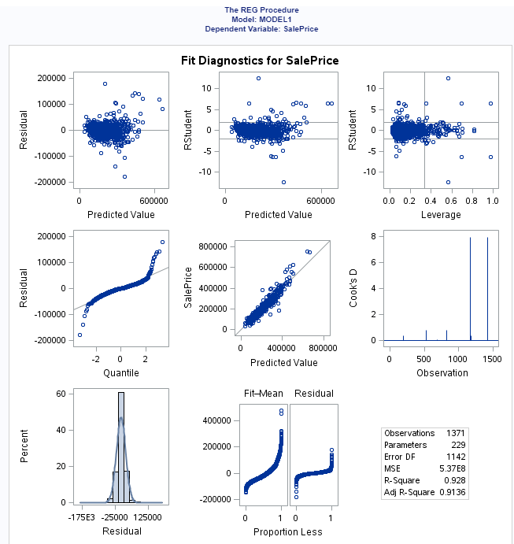

Plot Group 2B:

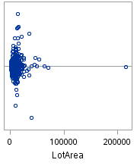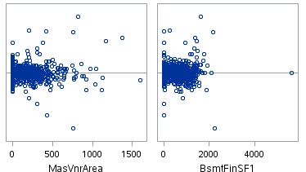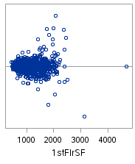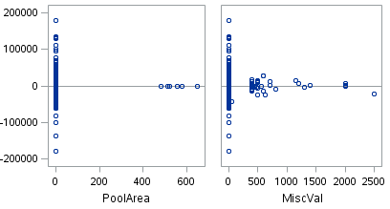

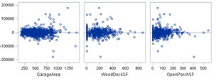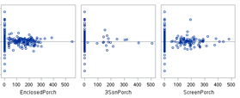

**Question 2 Prog Reg Output After Log Transformations:**

Plot Group 2C:

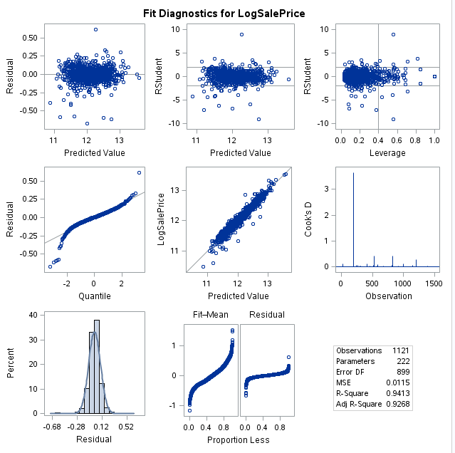

Plot Group 2D:

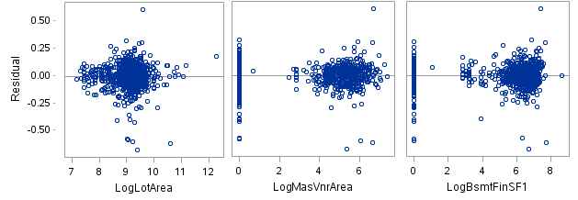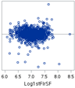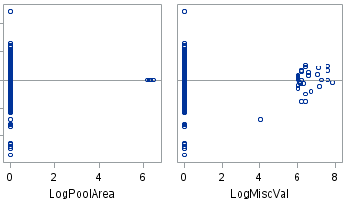

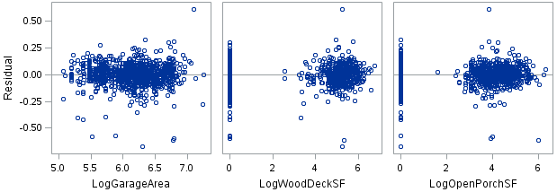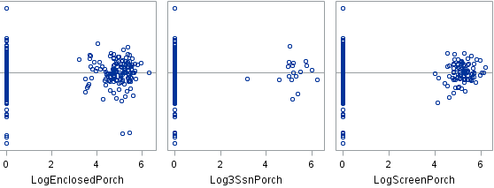

**Question 2 Forward Selection Output:**

Table 2E:

**The GLMSELECT Procedure**

|  |  |
| --- | --- |
| **Data Set** | WORK.TRAIN_DUMMY |
| **Dependent Variable** | LogSalePrice |
| **Selection Method** | Forward |
| **Select Criterion** | SBC |
| **Stop Criterion** | SBC |
| **Effect Hierarchy Enforced** | None |

|  |  |
| --- | --- |
| **Number of Observations Read** | 1460 |
| **Number of Observations Used** | 1121 |

| **Class Level Information** | | |
| --- | --- | --- |
| **Class** | **Levels** | **Values** |
| **MSZoning** | 5 | C FV RH RL RM |
| **Street** | 2 | Grvl Pave |
| **Alley** | 3 | Gr NA Pa |
| **LotShape** | 4 | IR1 IR2 IR3 Reg |
| **LandContour** | 4 | Bnk HLS Low Lvl |
| **Utilities** | 1 | AllPub |
| **LotConfig** | 5 | Corner CulDSac FR2 FR3 Inside |
| **LandSlope** | 3 | Gtl Mod Sev |
| **Neighborhood** | 25 | Blmngtn Blueste BrDale BrkSide ClearCr CollgCr Crawfor Edwards Gilbert IDOTRR MeadowV Mitchel NAmes NPkVill NWAmes NoRidge NridgHt OldTown SWISU Sawyer SawyerW Somerst StoneBr Timber Veenker |
| **Condition1** | 9 | Artery Feedr Norm PosA PosN RRAe RRAn RRNe RRNn |
| **Condition2** | 6 | Artery Feedr Norm PosA PosN RRNn |
| **BldgType** | 5 | 1Fam 2fmCon Duplex Twnhs TwnhsE |
| **HouseStyle** | 8 | 1.5Fin 1.5Unf 1Story 2.5Fin 2.5Unf 2Story SFoyer SLvl |
| **RoofStyle** | 5 | Flat Gable Gambr Hip Mansa |
| **RoofMatl** | 7 | ClyTile CompShg Membran Roll Tar&Grv WdShake WdShngl |
| **Exterior1st** | 14 | AsbShng BrkComm BrkFace CBlock CemntBd HdBoard ImStucc MetalSd Plywood Stone Stucco VinylSd Wd Sdng WdShing |
| **Exterior2nd** | 16 | AsbShng AsphShn Brk Cmn BrkFace CBlock CmentBd HdBoard ImStucc MetalSd Other Plywood Stone Stucco VinylSd Wd Sdng Wd Shng |
| **MasVnrType** | 4 | BrkCmn BrkFace None Stone |
| **ExterQual** | 4 | Ex Fa Gd TA |
| **ExterCond** | 4 | Ex Fa Gd TA |
| **Foundation** | 6 | BrkTil CBlock PConc Slab Stone Wood |
| **BsmtQual** | 5 | Ex Fa Gd NA TA |
| **BsmtCond** | 5 | Fa Gd NA Po TA |
| **BsmtExposure** | 5 | Av Gd Mn NA No |
| **BsmtFinType1** | 7 | ALQ BLQ GLQ LwQ NA Rec Unf |
| **BsmtFinType2** | 7 | ALQ BLQ GLQ LwQ NA Rec Unf |
| **Heating** | 5 | GasA GasW Grav OthW Wall |
| **HeatingQC** | 5 | Ex Fa Gd Po TA |
| **CentralAir** | 2 | N Y |
| **Electrical** | 6 | FuseA FuseF FuseP Mix NA SBrkr |
| **KitchenQual** | 4 | Ex Fa Gd TA |
| **Functional** | 6 | Maj1 Maj2 Min1 Min2 Mod Typ |
| **FireplaceQu** | 6 | Ex Fa Gd NA Po TA |
| **GarageType** | 6 | 2Types Attchd Basment BuiltIn CarPort Detchd |
| **GarageFinish** | 3 | Fin RFn Unf |
| **GarageQual** | 5 | Ex Fa Gd Po TA |
| **GarageCond** | 5 | Ex Fa Gd Po TA |
| **PavedDrive** | 3 | N P Y |
| **PoolQC** | 4 | Ex Fa Gd NA |
| **Fence** | 5 | GdPrv GdWo MnPrv MnWw NA |
| **MiscFeature** | 4 | NA Othr Shed TenC |
| **SaleType** | 6 | COD CWD Con New Oth WD |
| **SaleCondition** | 6 | Abnorml AdjLand Alloca Family Normal Partial |

| **Dimensions** | |
| --- | --- |
| **Number of Effects** | 78 |
| **Number of Parameters** | 285 |

**The GLMSELECT Procedure**

| **Forward Selection Summary** | | | | | | |
| --- | --- | --- | --- | --- | --- | --- |
| **Step** | **Effect Entered** | **Number Effects In** | **Number Parms In** | **Model R-Square** | **SBC** | **PRESS** |
| **\* Optimal Value of Criterion** | | | | | | |
| **0** | **Intercept** | 1 | 1 | 0.0000 | -2066.4335 | 176.6399 |
| **1** | **OverallQual** | 2 | 2 | 0.6851 | -3354.5767 | 55.7616 |
| **2** | **Log1stFlrSF** | 3 | 3 | 0.7412 | -3567.6573 | 45.9654 |
| **3** | **2ndFlrSF** | 4 | 4 | 0.7818 | -3751.9351 | 38.9323 |
| **4** | **YearBuilt** | 5 | 5 | 0.8147 | -3928.0564 | 33.1553 |
| **5** | **OverallCond** | 6 | 6 | 0.8382 | -4073.1053 | 29.0219 |
| **6** | **LogLotArea** | 7 | 7 | 0.8496 | -4147.7963 | 27.0661 |
| **7** | **RoofMatl** | 8 | 13 | 0.8656 | -4232.0952 | 24.1556 |
| **8** | **LogBsmtFinSF1** | 9 | 14 | 0.8744 | -4300.5435 | 22.6489 |
| **9** | **Neighborhood** | 10 | 38 | 0.8985 | -4371.1382 | 19.2971 |
| **10** | **GarageCars** | 11 | 39 | 0.9018 | -4400.6906 | 18.7174 |
| **11** | **KitchenAbvGr** | 12 | 40 | 0.9055 | -4436.9303 | 18.0567 |
| **12** | **MSZoning** | 13 | 44 | 0.9101 | -4465.5009 | 17.4914 |
| **13** | **Condition2** | 14 | 49 | 0.9154 | -4498.0609 | 18.8515 |
| **14** | **KitchenQual** | 15 | 52 | 0.9182 | -4514.9270 | 18.5146 |
| **15** | **SaleCondition** | 16 | 57 | 0.9214 | -4523.8525 | 18.2602 |
| **16** | **BsmtFullBath** | 17 | 58 | 0.9226 | -4533.9616 | 18.0625 |
| **17** | **CentralAir** | 18 | 59 | 0.9237 | -4542.9937 | 17.8060 |
| **18** | **GarageFinish** | 19 | 61 | 0.9250 | -4548.0730 | 17.5431 |
| **19** | **LogScreenPorch** | 20 | 62 | 0.9257 | -4552.6909 | 17.3707 |
| **20** | **LogOpenPorchSF** | 21 | 63 | 0.9263 | -4554.1894 | 17.2921 |
| **21** | **LogWoodDeckSF** | 22 | 64 | 0.9269 | -4555.8269* | 17.1852* |

|  |
| --- |
| Selection stopped at a local minimum of the SBC criterion. |

| **Stop Details** | | | | |
| --- | --- | --- | --- | --- |
| **Candidate For** | **Effect** | **Candidate SBC** |  | **Compare SBC** |
| **Entry** | LogEnclosedPorch | -4554.8188 | > | -4555.8269 |

**The GLMSELECT Procedure**

**Selected Model**

**The selected model is the model at the last step (Step 21).**

|  |  |
| --- | --- |
| **Effects:** | Intercept MSZoning LogLotArea Neighborhood Condition2 OverallQual OverallCond YearBuilt RoofMatl LogBsmtFinSF1 CentralAir Log1stFlrSF 2ndFlrSF BsmtFullBath KitchenAbvGr KitchenQual GarageFinish GarageCars LogWoodDeckSF LogOpenPorchSF LogScreenPorch SaleCondition |

| **Analysis of Variance** | | | | |
| --- | --- | --- | --- | --- |
| **Source** | **DF** | **Sum of Squares** | **Mean Square** | **F Value** |
| **Model** | 63 | 163.42779 | 2.59409 | 212.60 |
| **Error** | 1057 | 12.89713 | 0.01220 |  |
| **Corrected Total** | 1120 | 176.32491 |  |  |

|  |  |
| --- | --- |
| **Root MSE** | 0.11046 |
| **Dependent Mean** | 12.04841 |
| **R-Square** | 0.9269 |
| **Adj R-Sq** | 0.9225 |
| **AIC** | -3754.23342 |
| **AICC** | -3746.10071 |
| **PRESS** | 17.18516 |
| **SBC** | -4555.82692 |

| **Parameter Estimates** | | | | |
| --- | --- | --- | --- | --- |
| **Parameter** | **DF** | **Estimate** | **Standard Error** | **t Value** |
| **Intercept** | 1 | 2.433351 | 0.664000 | 3.66 |
| **MSZoning C** | 1 | -0.326476 | 0.045596 | -7.16 |
| **MSZoning FV** | 1 | 0.097795 | 0.034641 | 2.82 |
| **MSZoning RH** | 1 | 0.040363 | 0.040920 | 0.99 |
| **MSZoning RL** | 1 | 0.042573 | 0.018581 | 2.29 |
| **MSZoning RM** | 0 | 0 | . | . |
| **LogLotArea** | 1 | 0.095983 | 0.011631 | 8.25 |
| **Neighborhood Blmngtn** | 1 | -0.045403 | 0.054670 | -0.83 |
| **Neighborhood Blueste** | 1 | 0.016407 | 0.093330 | 0.18 |
| **Neighborhood BrDale** | 1 | 0.021599 | 0.058062 | 0.37 |
| **Neighborhood BrkSide** | 1 | 0.039986 | 0.050699 | 0.79 |
| **Neighborhood ClearCr** | 1 | -0.059126 | 0.054649 | -1.08 |
| **Neighborhood CollgCr** | 1 | -0.039486 | 0.044405 | -0.89 |
| **Neighborhood Crawfor** | 1 | 0.112287 | 0.047981 | 2.34 |
| **Neighborhood Edwards** | 1 | -0.123455 | 0.045871 | -2.69 |
| **Neighborhood Gilbert** | 1 | -0.045361 | 0.046535 | -0.97 |
| **Neighborhood IDOTRR** | 1 | 0.013611 | 0.055717 | 0.24 |
| **Neighborhood MeadowV** | 1 | -0.100128 | 0.060629 | -1.65 |
| **Neighborhood Mitchel** | 1 | -0.081181 | 0.047478 | -1.71 |
| **Neighborhood NAmes** | 1 | -0.077424 | 0.044332 | -1.75 |
| **Neighborhood NPkVill** | 1 | -0.026667 | 0.062613 | -0.43 |
| **Neighborhood NWAmes** | 1 | -0.106910 | 0.046026 | -2.32 |
| **Neighborhood NoRidge** | 1 | 0.019621 | 0.047888 | 0.41 |
| **Neighborhood NridgHt** | 1 | 0.062033 | 0.045641 | 1.36 |
| **Neighborhood OldTown** | 1 | -0.032773 | 0.050600 | -0.65 |
| **Neighborhood SWISU** | 1 | -0.022331 | 0.052776 | -0.42 |
| **Neighborhood Sawyer** | 1 | -0.094850 | 0.046484 | -2.04 |
| **Neighborhood SawyerW** | 1 | -0.068615 | 0.046367 | -1.48 |
| **Neighborhood Somerst** | 1 | -0.002462 | 0.050162 | -0.05 |
| **Neighborhood StoneBr** | 1 | 0.096736 | 0.050136 | 1.93 |
| **Neighborhood Timber** | 1 | -0.015773 | 0.047616 | -0.33 |
| **Neighborhood Veenker** | 0 | 0 | . | . |
| **Condition2 Artery** | 1 | -0.037195 | 0.115706 | -0.32 |
| **Condition2 Feedr** | 1 | -0.056835 | 0.094788 | -0.60 |
| **Condition2 Norm** | 1 | 0.068464 | 0.080871 | 0.85 |
| **Condition2 PosA** | 1 | 0.214739 | 0.139874 | 1.54 |
| **Condition2 PosN** | 1 | -0.634447 | 0.114831 | -5.53 |
| **Condition2 RRNn** | 0 | 0 | . | . |
| **OverallQual** | 1 | 0.058897 | 0.004808 | 12.25 |
| **OverallCond** | 1 | 0.047338 | 0.003995 | 11.85 |
| **YearBuilt** | 1 | 0.002621 | 0.000304 | 8.61 |
| **RoofMatl ClyTile** | 1 | -1.628480 | 0.124099 | -13.12 |
| **RoofMatl CompShg** | 1 | -0.132856 | 0.047591 | -2.79 |
| **RoofMatl Membran** | 1 | 0.022952 | 0.123788 | 0.19 |
| **RoofMatl Roll** | 1 | -0.130134 | 0.122264 | -1.06 |
| **RoofMatl Tar&Grv** | 1 | -0.202109 | 0.065408 | -3.09 |
| **RoofMatl WdShake** | 1 | -0.204848 | 0.092597 | -2.21 |
| **RoofMatl WdShngl** | 0 | 0 | . | . |
| **LogBsmtFinSF1** | 1 | 0.011119 | 0.001503 | 7.40 |
| **CentralAir N** | 1 | -0.073293 | 0.017521 | -4.18 |
| **CentralAir Y** | 0 | 0 | . | . |
| **Log1stFlrSF** | 1 | 0.404321 | 0.018699 | 21.62 |
| **2ndFlrSF** | 1 | 0.000246 | 0.000011022 | 22.29 |
| **BsmtFullBath** | 1 | 0.031820 | 0.008593 | 3.70 |
| **KitchenAbvGr** | 1 | -0.086124 | 0.020168 | -4.27 |
| **KitchenQual Ex** | 1 | 0.097355 | 0.018262 | 5.33 |
| **KitchenQual Fa** | 1 | -0.010269 | 0.025318 | -0.41 |
| **KitchenQual Gd** | 1 | 0.014719 | 0.010234 | 1.44 |
| **KitchenQual TA** | 0 | 0 | . | . |
| **GarageFinish Fin** | 1 | 0.042068 | 0.011788 | 3.57 |
| **GarageFinish RFn** | 1 | 0.030232 | 0.010220 | 2.96 |
| **GarageFinish Unf** | 0 | 0 | . | . |
| **GarageCars** | 1 | 0.059185 | 0.007604 | 7.78 |
| **LogWoodDeckSF** | 1 | 0.004205 | 0.001469 | 2.86 |
| **LogOpenPorchSF** | 1 | 0.005996 | 0.001976 | 3.03 |
| **LogScreenPorch** | 1 | 0.008624 | 0.002427 | 3.55 |
| **SaleCondition Abnorml** | 1 | -0.118718 | 0.018883 | -6.29 |
| **SaleCondition AdjLand** | 1 | 0.159529 | 0.113486 | 1.41 |
| **SaleCondition Alloca** | 1 | -0.133985 | 0.042298 | -3.17 |
| **SaleCondition Family** | 1 | -0.107906 | 0.029625 | -3.64 |
| **SaleCondition Normal** | 1 | -0.055147 | 0.012949 | -4.26 |
| **SaleCondition Partial** | 0 | 0 | . | . |

**The GLMSELECT Procedure**

|  |  |
| --- | --- |
| **Data Set** | WORK.TRAIN_DUMMY |
| **Dependent Variable** | LogSalePrice |
| **Selection Method** | Backward |
| **Select Criterion** | SBC |
| **Stop Criterion** | SBC |
| **Effect Hierarchy Enforced** | None |

|  |  |
| --- | --- |
| **Number of Observations Read** | 1460 |
| **Number of Observations Used** | 1121 |

| **Class Level Information** | | |
| --- | --- | --- |
| **Class** | **Levels** | **Values** |
| **MSZoning** | 5 | C FV RH RL RM |
| **Street** | 2 | Grvl Pave |
| **Alley** | 3 | Gr NA Pa |
| **LotShape** | 4 | IR1 IR2 IR3 Reg |
| **LandContour** | 4 | Bnk HLS Low Lvl |
| **Utilities** | 1 | AllPub |
| **LotConfig** | 5 | Corner CulDSac FR2 FR3 Inside |
| **LandSlope** | 3 | Gtl Mod Sev |
| **Neighborhood** | 25 | Blmngtn Blueste BrDale BrkSide ClearCr CollgCr Crawfor Edwards Gilbert IDOTRR MeadowV Mitchel NAmes NPkVill NWAmes NoRidge NridgHt OldTown SWISU Sawyer SawyerW Somerst StoneBr Timber Veenker |
| **Condition1** | 9 | Artery Feedr Norm PosA PosN RRAe RRAn RRNe RRNn |
| **Condition2** | 6 | Artery Feedr Norm PosA PosN RRNn |
| **BldgType** | 5 | 1Fam 2fmCon Duplex Twnhs TwnhsE |
| **HouseStyle** | 8 | 1.5Fin 1.5Unf 1Story 2.5Fin 2.5Unf 2Story SFoyer SLvl |
| **RoofStyle** | 5 | Flat Gable Gambr Hip Mansa |
| **RoofMatl** | 7 | ClyTile CompShg Membran Roll Tar&Grv WdShake WdShngl |
| **Exterior1st** | 14 | AsbShng BrkComm BrkFace CBlock CemntBd HdBoard ImStucc MetalSd Plywood Stone Stucco VinylSd Wd Sdng WdShing |
| **Exterior2nd** | 16 | AsbShng AsphShn Brk Cmn BrkFace CBlock CmentBd HdBoard ImStucc MetalSd Other Plywood Stone Stucco VinylSd Wd Sdng Wd Shng |
| **MasVnrType** | 4 | BrkCmn BrkFace None Stone |
| **ExterQual** | 4 | Ex Fa Gd TA |
| **ExterCond** | 4 | Ex Fa Gd TA |
| **Foundation** | 6 | BrkTil CBlock PConc Slab Stone Wood |
| **BsmtQual** | 5 | Ex Fa Gd NA TA |
| **BsmtCond** | 5 | Fa Gd NA Po TA |
| **BsmtExposure** | 5 | Av Gd Mn NA No |
| **BsmtFinType1** | 7 | ALQ BLQ GLQ LwQ NA Rec Unf |
| **BsmtFinType2** | 7 | ALQ BLQ GLQ LwQ NA Rec Unf |
| **Heating** | 5 | GasA GasW Grav OthW Wall |
| **HeatingQC** | 5 | Ex Fa Gd Po TA |
| **CentralAir** | 2 | N Y |
| **Electrical** | 6 | FuseA FuseF FuseP Mix NA SBrkr |
| **KitchenQual** | 4 | Ex Fa Gd TA |
| **Functional** | 6 | Maj1 Maj2 Min1 Min2 Mod Typ |
| **FireplaceQu** | 6 | Ex Fa Gd NA Po TA |
| **GarageType** | 6 | 2Types Attchd Basment BuiltIn CarPort Detchd |
| **GarageFinish** | 3 | Fin RFn Unf |
| **GarageQual** | 5 | Ex Fa Gd Po TA |
| **GarageCond** | 5 | Ex Fa Gd Po TA |
| **PavedDrive** | 3 | N P Y |
| **PoolQC** | 4 | Ex Fa Gd NA |
| **Fence** | 5 | GdPrv GdWo MnPrv MnWw NA |
| **MiscFeature** | 4 | NA Othr Shed TenC |
| **SaleType** | 6 | COD CWD Con New Oth WD |
| **SaleCondition** | 6 | Abnorml AdjLand Alloca Family Normal Partial |

| **Dimensions** | |
| --- | --- |
| **Number of Effects** | 78 |
| **Number of Parameters** | 285 |

**The GLMSELECT Procedure**

| **Backward Selection Summary** | | | | | | |
| --- | --- | --- | --- | --- | --- | --- |
| **Step** | **Effect Removed** | **Number Effects In** | **Number Parms In** | **Model R-Square** | **SBC** | **PRESS** |
| **\* Optimal Value of Criterion** | | | | | | |
| **0** |  | 78 | 238 | 0.9491 | -3741.3243 | 19.6953 |
|  | **Utilities** | 77 | 238 | 0.9491 | -3741.3243 | 19.6953 |
| **1** | **Exterior2nd** | 76 | 224 | 0.9479 | -3813.1678 | 19.1923 |
| **2** | **Exterior1st** | 75 | 211 | 0.9465 | -3873.6103 | 18.4814 |
| **3** | **HouseStyle** | 74 | 204 | 0.9461 | -3915.2076 | 18.4250 |
| **4** | **BsmtFinType2** | 73 | 198 | 0.9458 | -3951.0012 | 18.3605 |
| **5** | **FireplaceQu** | 72 | 193 | 0.9455 | -3980.4038 | 18.1648 |
| **6** | **GarageType** | 71 | 188 | 0.9452 | -4009.1920 | 18.1249 |
| **7** | **Condition1** | 70 | 180 | 0.9437 | -4034.9265 | 18.6901 |
| **8** | **Fence** | 69 | 176 | 0.9436 | -4059.9306 | 18.6099 |
| **9** | **RoofStyle** | 68 | 172 | 0.9433 | -4083.3905 | 18.5748 |
| **10** | **GarageQual** | 67 | 168 | 0.9430 | -4105.9290 | 17.9521 |
| **11** | **GarageCond** | 66 | 164 | 0.9428 | -4129.3149 | 17.8495 |
| **12** | **Electrical** | 65 | 160 | 0.9426 | -4152.9985 | 17.6752 |
| **13** | **BsmtFinType1** | 64 | 155 | 0.9420 | -4176.4612 | 17.6145 |
| **14** | **BldgType** | 63 | 151 | 0.9416 | -4197.8929 | 17.6004 |
| **15** | **LandContour** | 62 | 148 | 0.9416 | -4218.4252 | 17.3774 |
| **16** | **ExterQual** | 61 | 145 | 0.9415 | -4238.1265 | 17.2663 |
| **17** | **PoolQC** | 60 | 142 | 0.9414 | -4257.3543 | 17.3000 |
| **18** | **LotShape** | 59 | 139 | 0.9413 | -4275.7642 | 17.2720 |
| **19** | **BsmtCond** | 58 | 136 | 0.9411 | -4293.9910 | 17.1940 |
| **20** | **SaleType** | 57 | 131 | 0.9403 | -4312.3393 | 17.3116 |
| **21** | **MiscFeature** | 56 | 128 | 0.9400 | -4327.6418 | 17.1233 |
| **22** | **MasVnrType** | 55 | 125 | 0.9396 | -4342.2036 | 16.8879* |
| **23** | **BsmtQual** | 54 | 121 | 0.9388 | -4355.7520 | 16.9598 |
| **24** | **LotConfig** | 53 | 117 | 0.9380 | -4368.7718 | 17.0984 |
| **25** | **ExterCond** | 52 | 114 | 0.9376 | -4382.4912 | 17.0384 |
| **26** | **Foundation** | 51 | 109 | 0.9363 | -4395.2047 | 17.1120 |
| **27** | **PavedDrive** | 50 | 107 | 0.9362 | -4406.6127 | 17.1010 |
| **28** | **Alley** | 49 | 105 | 0.9359 | -4416.3882 | 17.0622 |
| **29** | **GarageFinish** | 48 | 103 | 0.9357 | -4425.8371 | 17.1176 |
| **30** | **HeatingQC** | 47 | 99 | 0.9345 | -4433.3414 | 17.3184 |
| **31** | **Heating** | 46 | 95 | 0.9333 | -4441.0348 | 17.6711 |
| **32** | **LandSlope** | 45 | 93 | 0.9329 | -4449.0608 | 17.4035 |
| **33** | **BsmtUnfSF** | 44 | 92 | 0.9329 | -4456.0320 | 17.3515 |
| **34** | **YrSold** | 43 | 91 | 0.9329 | -4462.9677 | 17.3242 |
| **35** | **LogMasVnrArea** | 42 | 90 | 0.9329 | -4469.8403 | 17.3057 |
| **36** | **BsmtHalfBath** | 41 | 89 | 0.9329 | -4476.5359 | 17.2867 |
| **37** | **IntLotFrontage** | 40 | 88 | 0.9328 | -4483.0655 | 17.2637 |
| **38** | **LowQualFinSF** | 39 | 87 | 0.9328 | -4489.4381 | 17.2378 |
| **39** | **LogMiscVal** | 38 | 86 | 0.9328 | -4495.7733 | 17.2248 |
| **40** | **BsmtFinSF2** | 37 | 85 | 0.9327 | -4501.7542 | 17.2312 |
| **41** | **GarageYrBlt** | 36 | 84 | 0.9326 | -4507.6361 | 17.1765 |
| **42** | **MSSubClass** | 35 | 83 | 0.9326 | -4513.3747 | 17.1732 |
| **43** | **LogPoolArea** | 34 | 82 | 0.9325 | -4519.0627 | 17.1502 |
| **44** | **Log3SsnPorch** | 33 | 81 | 0.9324 | -4524.3939 | 17.1419 |
| **45** | **MoSold** | 32 | 80 | 0.9323 | -4529.5626 | 17.1569 |
| **46** | **TotRmsAbvGrd** | 31 | 79 | 0.9321 | -4534.3710 | 17.1642 |
| **47** | **BedroomAbvGr** | 30 | 78 | 0.9321 | -4540.2189 | 17.0594 |
| **48** | **LogEnclosedPorch** | 29 | 77 | 0.9318 | -4543.5440 | 17.0665 |
| **49** | **LogGarageArea** | 28 | 76 | 0.9315 | -4545.3370 | 17.1443 |
| **50** | **HalfBath** | 27 | 75 | 0.9312 | -4547.3069 | 17.1776 |
| **51** | **BsmtExposure** | 26 | 71 | 0.9296 | -4549.1911 | 17.0857 |
| **52** | **Street** | 25 | 70 | 0.9293 | -4551.9157 | 17.0834 |
| **53** | **FullBath** | 24 | 69 | 0.9289 | -4553.2699 | 17.0938 |
| **54** | **Fireplaces** | 23 | 68 | 0.9285 | -4553.8875* | 17.1811 |

**Note:**Effects dropped at step 0 are redundant.

|  |
| --- |
| Selection stopped at a local minimum of the SBC criterion. |

| **Stop Details** | | | | |
| --- | --- | --- | --- | --- |
| **Candidate For** | **Effect** | **Candidate SBC** |  | **Compare SBC** |
| **Removal** | Functional | -4553.0503 | > | -4553.8875 |

**The GLMSELECT Procedure**

**Selected Model**

**The selected model is the model at the last step (Step 54).**

|  |  |
| --- | --- |
| **Effects:** | Intercept MSZoning LogLotArea Neighborhood Condition2 OverallQual OverallCond YearBuilt YearRemodAdd RoofMatl LogBsmtFinSF1 CentralAir Log1stFlrSF 2ndFlrSF BsmtFullBath KitchenAbvGr KitchenQual Functional GarageCars LogWoodDeckSF LogOpenPorchSF LogScreenPorch SaleCondition |

| **Analysis of Variance** | | | | |
| --- | --- | --- | --- | --- |
| **Source** | **DF** | **Sum of Squares** | **Mean Square** | **F Value** |
| **Model** | 67 | 163.72514 | 2.44366 | 204.22 |
| **Error** | 1053 | 12.59977 | 0.01197 |  |
| **Corrected Total** | 1120 | 176.32491 |  |  |

|  |  |
| --- | --- |
| **Root MSE** | 0.10939 |
| **Dependent Mean** | 12.04841 |
| **R-Square** | 0.9285 |
| **Adj R-Sq** | 0.9240 |
| **AIC** | -3772.38187 |
| **AICC** | -3763.19062 |
| **PRESS** | 17.18111 |
| **SBC** | -4553.88747 |

| **Parameter Estimates** | | | | |
| --- | --- | --- | --- | --- |
| **Parameter** | **DF** | **Estimate** | **Standard Error** | **t Value** |
| **Intercept** | 1 | 0.924064 | 0.755859 | 1.22 |
| **MSZoning C** | 1 | -0.327061 | 0.045026 | -7.26 |
| **MSZoning FV** | 1 | 0.098583 | 0.034384 | 2.87 |
| **MSZoning RH** | 1 | 0.033519 | 0.040576 | 0.83 |
| **MSZoning RL** | 1 | 0.042862 | 0.018499 | 2.32 |
| **MSZoning RM** | 0 | 0 | . | . |
| **LogLotArea** | 1 | 0.094030 | 0.011642 | 8.08 |
| **Neighborhood Blmngtn** | 1 | -0.059404 | 0.054086 | -1.10 |
| **Neighborhood Blueste** | 1 | 0.035772 | 0.092322 | 0.39 |
| **Neighborhood BrDale** | 1 | 0.011598 | 0.057416 | 0.20 |
| **Neighborhood BrkSide** | 1 | 0.033468 | 0.050141 | 0.67 |
| **Neighborhood ClearCr** | 1 | -0.066868 | 0.054110 | -1.24 |
| **Neighborhood CollgCr** | 1 | -0.058847 | 0.043929 | -1.34 |
| **Neighborhood Crawfor** | 1 | 0.102033 | 0.047417 | 2.15 |
| **Neighborhood Edwards** | 1 | -0.130993 | 0.045369 | -2.89 |
| **Neighborhood Gilbert** | 1 | -0.054583 | 0.046118 | -1.18 |
| **Neighborhood IDOTRR** | 1 | 0.009742 | 0.055145 | 0.18 |
| **Neighborhood MeadowV** | 1 | -0.107620 | 0.060020 | -1.79 |
| **Neighborhood Mitchel** | 1 | -0.096081 | 0.046942 | -2.05 |
| **Neighborhood NAmes** | 1 | -0.079271 | 0.043874 | -1.81 |
| **Neighborhood NPkVill** | 1 | -0.047545 | 0.061855 | -0.77 |
| **Neighborhood NWAmes** | 1 | -0.111066 | 0.045547 | -2.44 |
| **Neighborhood NoRidge** | 1 | -0.000878 | 0.047400 | -0.02 |
| **Neighborhood NridgHt** | 1 | 0.040038 | 0.045142 | 0.89 |
| **Neighborhood OldTown** | 1 | -0.042151 | 0.050029 | -0.84 |
| **Neighborhood SWISU** | 1 | -0.028047 | 0.052213 | -0.54 |
| **Neighborhood Sawyer** | 1 | -0.098698 | 0.046039 | -2.14 |
| **Neighborhood SawyerW** | 1 | -0.088909 | 0.045757 | -1.94 |
| **Neighborhood Somerst** | 1 | -0.024130 | 0.049629 | -0.49 |
| **Neighborhood StoneBr** | 1 | 0.083604 | 0.049659 | 1.68 |
| **Neighborhood Timber** | 1 | -0.028047 | 0.047171 | -0.59 |
| **Neighborhood Veenker** | 0 | 0 | . | . |
| **Condition2 Artery** | 1 | -0.038382 | 0.114593 | -0.33 |
| **Condition2 Feedr** | 1 | -0.071294 | 0.093752 | -0.76 |
| **Condition2 Norm** | 1 | 0.055885 | 0.079951 | 0.70 |
| **Condition2 PosA** | 1 | 0.178098 | 0.138286 | 1.29 |
| **Condition2 PosN** | 1 | -0.662616 | 0.113545 | -5.84 |
| **Condition2 RRNn** | 0 | 0 | . | . |
| **OverallQual** | 1 | 0.058723 | 0.004789 | 12.26 |
| **OverallCond** | 1 | 0.038043 | 0.004371 | 8.70 |
| **YearBuilt** | 1 | 0.002556 | 0.000308 | 8.31 |
| **YearRemodAdd** | 1 | 0.000795 | 0.000275 | 2.90 |
| **RoofMatl ClyTile** | 1 | -1.660946 | 0.122995 | -13.50 |
| **RoofMatl CompShg** | 1 | -0.124295 | 0.047165 | -2.64 |
| **RoofMatl Membran** | 1 | 0.078112 | 0.127982 | 0.61 |
| **RoofMatl Roll** | 1 | -0.126267 | 0.121087 | -1.04 |
| **RoofMatl Tar&Grv** | 1 | -0.202707 | 0.064831 | -3.13 |
| **RoofMatl WdShake** | 1 | -0.201635 | 0.091645 | -2.20 |
| **RoofMatl WdShngl** | 0 | 0 | . | . |
| **LogBsmtFinSF1** | 1 | 0.011271 | 0.001498 | 7.52 |
| **CentralAir N** | 1 | -0.070558 | 0.017424 | -4.05 |
| **CentralAir Y** | 0 | 0 | . | . |
| **Log1stFlrSF** | 1 | 0.430404 | 0.019114 | 22.52 |
| **2ndFlrSF** | 1 | 0.000255 | 0.000011073 | 22.99 |
| **BsmtFullBath** | 1 | 0.031243 | 0.008552 | 3.65 |
| **KitchenAbvGr** | 1 | -0.097749 | 0.019993 | -4.89 |
| **KitchenQual Ex** | 1 | 0.090268 | 0.018258 | 4.94 |
| **KitchenQual Fa** | 1 | -0.007589 | 0.025224 | -0.30 |
| **KitchenQual Gd** | 1 | 0.007415 | 0.010725 | 0.69 |
| **KitchenQual TA** | 0 | 0 | . | . |
| **Functional Maj1** | 1 | -0.085603 | 0.036785 | -2.33 |
| **Functional Maj2** | 1 | -0.197489 | 0.057037 | -3.46 |
| **Functional Min1** | 1 | -0.071853 | 0.023495 | -3.06 |
| **Functional Min2** | 1 | -0.058743 | 0.023057 | -2.55 |
| **Functional Mod** | 1 | -0.080600 | 0.034424 | -2.34 |
| **Functional Typ** | 0 | 0 | . | . |
| **GarageCars** | 1 | 0.056376 | 0.007557 | 7.46 |
| **LogWoodDeckSF** | 1 | 0.004424 | 0.001459 | 3.03 |
| **LogOpenPorchSF** | 1 | 0.006393 | 0.001943 | 3.29 |
| **LogScreenPorch** | 1 | 0.008940 | 0.002405 | 3.72 |
| **SaleCondition Abnorml** | 1 | -0.115983 | 0.018737 | -6.19 |
| **SaleCondition AdjLand** | 1 | 0.165892 | 0.112528 | 1.47 |
| **SaleCondition Alloca** | 1 | -0.147734 | 0.041893 | -3.53 |
| **SaleCondition Family** | 1 | -0.111411 | 0.029362 | -3.79 |
| **SaleCondition Normal** | 1 | -0.052079 | 0.012849 | -4.05 |
| **SaleCondition Partial** | 0 | 0 | . | . |

**The GLMSELECT Procedure**

|  |  |
| --- | --- |
| **Data Set** | WORK.TRAIN_DUMMY |
| **Dependent Variable** | LogSalePrice |
| **Selection Method** | Stepwise |
| **Select Criterion** | SBC |
| **Stop Criterion** | SBC |
| **Effect Hierarchy Enforced** | None |

|  |  |
| --- | --- |
| **Number of Observations Read** | 1460 |
| **Number of Observations Used** | 1121 |

| **Class Level Information** | | |
| --- | --- | --- |
| **Class** | **Levels** | **Values** |
| **MSZoning** | 5 | C FV RH RL RM |
| **Street** | 2 | Grvl Pave |
| **Alley** | 3 | Gr NA Pa |
| **LotShape** | 4 | IR1 IR2 IR3 Reg |
| **LandContour** | 4 | Bnk HLS Low Lvl |
| **Utilities** | 1 | AllPub |
| **LotConfig** | 5 | Corner CulDSac FR2 FR3 Inside |
| **LandSlope** | 3 | Gtl Mod Sev |
| **Neighborhood** | 25 | Blmngtn Blueste BrDale BrkSide ClearCr CollgCr Crawfor Edwards Gilbert IDOTRR MeadowV Mitchel NAmes NPkVill NWAmes NoRidge NridgHt OldTown SWISU Sawyer SawyerW Somerst StoneBr Timber Veenker |
| **Condition1** | 9 | Artery Feedr Norm PosA PosN RRAe RRAn RRNe RRNn |
| **Condition2** | 6 | Artery Feedr Norm PosA PosN RRNn |
| **BldgType** | 5 | 1Fam 2fmCon Duplex Twnhs TwnhsE |
| **HouseStyle** | 8 | 1.5Fin 1.5Unf 1Story 2.5Fin 2.5Unf 2Story SFoyer SLvl |
| **RoofStyle** | 5 | Flat Gable Gambr Hip Mansa |
| **RoofMatl** | 7 | ClyTile CompShg Membran Roll Tar&Grv WdShake WdShngl |
| **Exterior1st** | 14 | AsbShng BrkComm BrkFace CBlock CemntBd HdBoard ImStucc MetalSd Plywood Stone Stucco VinylSd Wd Sdng WdShing |
| **Exterior2nd** | 16 | AsbShng AsphShn Brk Cmn BrkFace CBlock CmentBd HdBoard ImStucc MetalSd Other Plywood Stone Stucco VinylSd Wd Sdng Wd Shng |
| **MasVnrType** | 4 | BrkCmn BrkFace None Stone |
| **ExterQual** | 4 | Ex Fa Gd TA |
| **ExterCond** | 4 | Ex Fa Gd TA |
| **Foundation** | 6 | BrkTil CBlock PConc Slab Stone Wood |
| **BsmtQual** | 5 | Ex Fa Gd NA TA |
| **BsmtCond** | 5 | Fa Gd NA Po TA |
| **BsmtExposure** | 5 | Av Gd Mn NA No |
| **BsmtFinType1** | 7 | ALQ BLQ GLQ LwQ NA Rec Unf |
| **BsmtFinType2** | 7 | ALQ BLQ GLQ LwQ NA Rec Unf |
| **Heating** | 5 | GasA GasW Grav OthW Wall |
| **HeatingQC** | 5 | Ex Fa Gd Po TA |
| **CentralAir** | 2 | N Y |
| **Electrical** | 6 | FuseA FuseF FuseP Mix NA SBrkr |
| **KitchenQual** | 4 | Ex Fa Gd TA |
| **Functional** | 6 | Maj1 Maj2 Min1 Min2 Mod Typ |
| **FireplaceQu** | 6 | Ex Fa Gd NA Po TA |
| **GarageType** | 6 | 2Types Attchd Basment BuiltIn CarPort Detchd |
| **GarageFinish** | 3 | Fin RFn Unf |
| **GarageQual** | 5 | Ex Fa Gd Po TA |
| **GarageCond** | 5 | Ex Fa Gd Po TA |
| **PavedDrive** | 3 | N P Y |
| **PoolQC** | 4 | Ex Fa Gd NA |
| **Fence** | 5 | GdPrv GdWo MnPrv MnWw NA |
| **MiscFeature** | 4 | NA Othr Shed TenC |
| **SaleType** | 6 | COD CWD Con New Oth WD |
| **SaleCondition** | 6 | Abnorml AdjLand Alloca Family Normal Partial |

| **Dimensions** | |
| --- | --- |
| **Number of Effects** | 78 |
| **Number of Parameters** | 285 |

**The GLMSELECT Procedure**

| **Stepwise Selection Summary** | | | | | | | |
| --- | --- | --- | --- | --- | --- | --- | --- |
| **Step** | **Effect Entered** | **Effect Removed** | **Number Effects In** | **Number Parms In** | **Model R-Square** | **SBC** | **PRESS** |
| **\* Optimal Value of Criterion** | | | | | | | |
| **0** | **Intercept** |  | 1 | 1 | 0.0000 | -2066.4335 | 176.6399 |
| **1** | **OverallQual** |  | 2 | 2 | 0.6851 | -3354.5767 | 55.7616 |
| **2** | **Log1stFlrSF** |  | 3 | 3 | 0.7412 | -3567.6573 | 45.9654 |
| **3** | **2ndFlrSF** |  | 4 | 4 | 0.7818 | -3751.9351 | 38.9323 |
| **4** | **YearBuilt** |  | 5 | 5 | 0.8147 | -3928.0564 | 33.1553 |
| **5** | **OverallCond** |  | 6 | 6 | 0.8382 | -4073.1053 | 29.0219 |
| **6** | **LogLotArea** |  | 7 | 7 | 0.8496 | -4147.7963 | 27.0661 |
| **7** | **RoofMatl** |  | 8 | 13 | 0.8656 | -4232.0952 | 24.1556 |
| **8** | **LogBsmtFinSF1** |  | 9 | 14 | 0.8744 | -4300.5435 | 22.6489 |
| **9** | **Neighborhood** |  | 10 | 38 | 0.8985 | -4371.1382 | 19.2971 |
| **10** | **GarageCars** |  | 11 | 39 | 0.9018 | -4400.6906 | 18.7174 |
| **11** | **KitchenAbvGr** |  | 12 | 40 | 0.9055 | -4436.9303 | 18.0567 |
| **12** | **MSZoning** |  | 13 | 44 | 0.9101 | -4465.5009 | 17.4914 |
| **13** | **Condition2** |  | 14 | 49 | 0.9154 | -4498.0609 | 18.8515 |
| **14** | **KitchenQual** |  | 15 | 52 | 0.9182 | -4514.9270 | 18.5146 |
| **15** | **SaleCondition** |  | 16 | 57 | 0.9214 | -4523.8525 | 18.2602 |
| **16** | **BsmtFullBath** |  | 17 | 58 | 0.9226 | -4533.9616 | 18.0625 |
| **17** | **CentralAir** |  | 18 | 59 | 0.9237 | -4542.9937 | 17.8060 |
| **18** | **GarageFinish** |  | 19 | 61 | 0.9250 | -4548.0730 | 17.5431 |
| **19** | **LogScreenPorch** |  | 20 | 62 | 0.9257 | -4552.6909 | 17.3707 |
| **20** | **LogOpenPorchSF** |  | 21 | 63 | 0.9263 | -4554.1894 | 17.2921 |
| **21** | **LogWoodDeckSF** |  | 22 | 64 | 0.9269 | -4555.8269* | 17.1852* |

|  |
| --- |
| Selection stopped at a local minimum of the SBC criterion. |

| **Stop Details** | | | | |
| --- | --- | --- | --- | --- |
| **Candidate For** | **Effect** | **Candidate SBC** |  | **Compare SBC** |
| **Entry** | LogEnclosedPorch | -4554.8188 | > | -4555.8269 |
| **Removal** | GarageFinish | -4555.2554 | > | -4555.8269 |

**The GLMSELECT Procedure**

**Selected Model**

**The selected model is the model at the last step (Step 21).**

|  |  |
| --- | --- |
| **Effects:** | Intercept MSZoning LogLotArea Neighborhood Condition2 OverallQual OverallCond YearBuilt RoofMatl LogBsmtFinSF1 CentralAir Log1stFlrSF 2ndFlrSF BsmtFullBath KitchenAbvGr KitchenQual GarageFinish GarageCars LogWoodDeckSF LogOpenPorchSF LogScreenPorch SaleCondition |

| **Analysis of Variance** | | | | |
| --- | --- | --- | --- | --- |
| **Source** | **DF** | **Sum of Squares** | **Mean Square** | **F Value** |
| **Model** | 63 | 163.42779 | 2.59409 | 212.60 |
| **Error** | 1057 | 12.89713 | 0.01220 |  |
| **Corrected Total** | 1120 | 176.32491 |  |  |

|  |  |
| --- | --- |
| **Root MSE** | 0.11046 |
| **Dependent Mean** | 12.04841 |
| **R-Square** | 0.9269 |
| **Adj R-Sq** | 0.9225 |
| **AIC** | -3754.23342 |
| **AICC** | -3746.10071 |
| **PRESS** | 17.18516 |
| **SBC** | -4555.82692 |

| **Parameter Estimates** | | | | |
| --- | --- | --- | --- | --- |
| **Parameter** | **DF** | **Estimate** | **Standard Error** | **t Value** |
| **Intercept** | 1 | 2.433351 | 0.664000 | 3.66 |
| **MSZoning C** | 1 | -0.326476 | 0.045596 | -7.16 |
| **MSZoning FV** | 1 | 0.097795 | 0.034641 | 2.82 |
| **MSZoning RH** | 1 | 0.040363 | 0.040920 | 0.99 |
| **MSZoning RL** | 1 | 0.042573 | 0.018581 | 2.29 |
| **MSZoning RM** | 0 | 0 | . | . |
| **LogLotArea** | 1 | 0.095983 | 0.011631 | 8.25 |
| **Neighborhood Blmngtn** | 1 | -0.045403 | 0.054670 | -0.83 |
| **Neighborhood Blueste** | 1 | 0.016407 | 0.093330 | 0.18 |
| **Neighborhood BrDale** | 1 | 0.021599 | 0.058062 | 0.37 |
| **Neighborhood BrkSide** | 1 | 0.039986 | 0.050699 | 0.79 |
| **Neighborhood ClearCr** | 1 | -0.059126 | 0.054649 | -1.08 |
| **Neighborhood CollgCr** | 1 | -0.039486 | 0.044405 | -0.89 |
| **Neighborhood Crawfor** | 1 | 0.112287 | 0.047981 | 2.34 |
| **Neighborhood Edwards** | 1 | -0.123455 | 0.045871 | -2.69 |
| **Neighborhood Gilbert** | 1 | -0.045361 | 0.046535 | -0.97 |
| **Neighborhood IDOTRR** | 1 | 0.013611 | 0.055717 | 0.24 |
| **Neighborhood MeadowV** | 1 | -0.100128 | 0.060629 | -1.65 |
| **Neighborhood Mitchel** | 1 | -0.081181 | 0.047478 | -1.71 |
| **Neighborhood NAmes** | 1 | -0.077424 | 0.044332 | -1.75 |
| **Neighborhood NPkVill** | 1 | -0.026667 | 0.062613 | -0.43 |
| **Neighborhood NWAmes** | 1 | -0.106910 | 0.046026 | -2.32 |
| **Neighborhood NoRidge** | 1 | 0.019621 | 0.047888 | 0.41 |
| **Neighborhood NridgHt** | 1 | 0.062033 | 0.045641 | 1.36 |
| **Neighborhood OldTown** | 1 | -0.032773 | 0.050600 | -0.65 |
| **Neighborhood SWISU** | 1 | -0.022331 | 0.052776 | -0.42 |
| **Neighborhood Sawyer** | 1 | -0.094850 | 0.046484 | -2.04 |
| **Neighborhood SawyerW** | 1 | -0.068615 | 0.046367 | -1.48 |
| **Neighborhood Somerst** | 1 | -0.002462 | 0.050162 | -0.05 |
| **Neighborhood StoneBr** | 1 | 0.096736 | 0.050136 | 1.93 |
| **Neighborhood Timber** | 1 | -0.015773 | 0.047616 | -0.33 |
| **Neighborhood Veenker** | 0 | 0 | . | . |
| **Condition2 Artery** | 1 | -0.037195 | 0.115706 | -0.32 |
| **Condition2 Feedr** | 1 | -0.056835 | 0.094788 | -0.60 |
| **Condition2 Norm** | 1 | 0.068464 | 0.080871 | 0.85 |
| **Condition2 PosA** | 1 | 0.214739 | 0.139874 | 1.54 |
| **Condition2 PosN** | 1 | -0.634447 | 0.114831 | -5.53 |
| **Condition2 RRNn** | 0 | 0 | . | . |
| **OverallQual** | 1 | 0.058897 | 0.004808 | 12.25 |
| **OverallCond** | 1 | 0.047338 | 0.003995 | 11.85 |
| **YearBuilt** | 1 | 0.002621 | 0.000304 | 8.61 |
| **RoofMatl ClyTile** | 1 | -1.628480 | 0.124099 | -13.12 |
| **RoofMatl CompShg** | 1 | -0.132856 | 0.047591 | -2.79 |
| **RoofMatl Membran** | 1 | 0.022952 | 0.123788 | 0.19 |
| **RoofMatl Roll** | 1 | -0.130134 | 0.122264 | -1.06 |
| **RoofMatl Tar&Grv** | 1 | -0.202109 | 0.065408 | -3.09 |
| **RoofMatl WdShake** | 1 | -0.204848 | 0.092597 | -2.21 |
| **RoofMatl WdShngl** | 0 | 0 | . | . |
| **LogBsmtFinSF1** | 1 | 0.011119 | 0.001503 | 7.40 |
| **CentralAir N** | 1 | -0.073293 | 0.017521 | -4.18 |
| **CentralAir Y** | 0 | 0 | . | . |
| **Log1stFlrSF** | 1 | 0.404321 | 0.018699 | 21.62 |
| **2ndFlrSF** | 1 | 0.000246 | 0.000011022 | 22.29 |
| **BsmtFullBath** | 1 | 0.031820 | 0.008593 | 3.70 |
| **KitchenAbvGr** | 1 | -0.086124 | 0.020168 | -4.27 |
| **KitchenQual Ex** | 1 | 0.097355 | 0.018262 | 5.33 |
| **KitchenQual Fa** | 1 | -0.010269 | 0.025318 | -0.41 |
| **KitchenQual Gd** | 1 | 0.014719 | 0.010234 | 1.44 |
| **KitchenQual TA** | 0 | 0 | . | . |
| **GarageFinish Fin** | 1 | 0.042068 | 0.011788 | 3.57 |
| **GarageFinish RFn** | 1 | 0.030232 | 0.010220 | 2.96 |
| **GarageFinish Unf** | 0 | 0 | . | . |
| **GarageCars** | 1 | 0.059185 | 0.007604 | 7.78 |
| **LogWoodDeckSF** | 1 | 0.004205 | 0.001469 | 2.86 |
| **LogOpenPorchSF** | 1 | 0.005996 | 0.001976 | 3.03 |
| **LogScreenPorch** | 1 | 0.008624 | 0.002427 | 3.55 |
| **SaleCondition Abnorml** | 1 | -0.118718 | 0.018883 | -6.29 |
| **SaleCondition AdjLand** | 1 | 0.159529 | 0.113486 | 1.41 |
| **SaleCondition Alloca** | 1 | -0.133985 | 0.042298 | -3.17 |
| **SaleCondition Family** | 1 | -0.107906 | 0.029625 | -3.64 |
| **SaleCondition Normal** | 1 | -0.055147 | 0.012949 | -4.26 |
| **SaleCondition Partial** | 0 | 0 | . | . |

Table 2H:

**The GLMSELECT Procedure**

|  |  |
| --- | --- |
| **Data Set** | WORK.TRAIN_DUMMY |
| **Dependent Variable** | LogSalePrice |
| **Selection Method** | Forward |
| **Select Criterion** | Significance Level |
| **Stop Criterion** | Significance Level |
| **Entry Significance Level (SLE)** | 0.5 |
| **Effect Hierarchy Enforced** | None |

|  |  |
| --- | --- |
| **Number of Observations Read** | 1460 |
| **Number of Observations Used** | 1127 |

| **Class Level Information** | | |
| --- | --- | --- |
| **Class** | **Levels** | **Values** |
| **MSZoning** | 5 | C FV RH RL RM |
| **Street** | 2 | Grvl Pave |
| **Alley** | 3 | Gr NA Pa |
| **LotShape** | 4 | IR1 IR2 IR3 Reg |
| **Utilities** | 1 | AllPub |
| **LotConfig** | 5 | Corner CulDSac FR2 FR3 Inside |
| **LandSlope** | 3 | Gtl Mod Sev |
| **Neighborhood** | 25 | Blmngtn Blueste BrDale BrkSide ClearCr CollgCr Crawfor Edwards Gilbert IDOTRR MeadowV Mitchel NAmes NPkVill NWAmes NoRidge NridgHt OldTown SWISU Sawyer SawyerW Somerst StoneBr Timber Veenker |
| **Condition1** | 9 | Artery Feedr Norm PosA PosN RRAe RRAn RRNe RRNn |
| **Condition2** | 6 | Artery Feedr Norm PosA PosN RRNn |
| **BldgType** | 5 | 1Fam 2fmCon Duplex Twnhs TwnhsE |
| **RoofMatl** | 7 | ClyTile CompShg Membran Roll Tar&Grv WdShake WdShngl |
| **Exterior1st** | 14 | AsbShng BrkComm BrkFace CBlock CemntBd HdBoard ImStucc MetalSd Plywood Stone Stucco VinylSd Wd Sdng WdShing |
| **Exterior2nd** | 16 | AsbShng AsphShn Brk Cmn BrkFace CBlock CmentBd HdBoard ImStucc MetalSd Other Plywood Stone Stucco VinylSd Wd Sdng Wd Shng |
| **MasVnrType** | 5 | BrkCmn BrkFace NA None Stone |
| **ExterCond** | 4 | Ex Fa Gd TA |
| **Foundation** | 6 | BrkTil CBlock PConc Slab Stone Wood |
| **BsmtQual** | 5 | Ex Fa Gd NA TA |
| **BsmtCond** | 5 | Fa Gd NA Po TA |
| **BsmtExposure** | 5 | Av Gd Mn NA No |
| **BsmtFinType1** | 7 | ALQ BLQ GLQ LwQ NA Rec Unf |
| **Heating** | 5 | GasA GasW Grav OthW Wall |
| **HeatingQC** | 5 | Ex Fa Gd Po TA |
| **CentralAir** | 2 | N Y |
| **KitchenQual** | 4 | Ex Fa Gd TA |
| **Functional** | 6 | Maj1 Maj2 Min1 Min2 Mod Typ |
| **GarageType** | 6 | 2Types Attchd Basment BuiltIn CarPort Detchd |
| **GarageFinish** | 3 | Fin RFn Unf |
| **GarageQual** | 5 | Ex Fa Gd Po TA |
| **GarageCond** | 5 | Ex Fa Gd Po TA |
| **PavedDrive** | 3 | N P Y |
| **PoolQC** | 4 | Ex Fa Gd NA |
| **Fence** | 5 | GdPrv GdWo MnPrv MnWw NA |
| **SaleType** | 6 | COD CWD Con New Oth WD |
| **SaleCondition** | 6 | Abnorml AdjLand Alloca Family Normal Partial |

| **Dimensions** | |
| --- | --- |
| **Number of Effects** | 61 |
| **Number of Parameters** | 229 |

**The GLMSELECT Procedure**

| **Forward Selection Summary** | | | | | | | |
| --- | --- | --- | --- | --- | --- | --- | --- |
| **Step** | **Effect Entered** | **Number Effects In** | **Number Parms In** | **Model R-Square** | **PRESS** | **F Value** | **Pr > F** |
| **\* Optimal Value of Criterion** | | | | | | | |
| **0** | **Intercept** | 1 | 1 | 0.0000 | 177.8173 | 0.00 | 1.0000 |
| **1** | **OverallQual** | 2 | 2 | 0.6869 | 55.8077 | 2467.85 | <.0001 |
| **2** | **Neighborhood** | 3 | 26 | 0.7615 | 44.4759 | 14.34 | <.0001 |
| **3** | **TotRmsAbvGrd** | 4 | 27 | 0.7979 | 37.7749 | 198.01 | <.0001 |
| **4** | **Log1stFlrSF** | 5 | 28 | 0.8203 | 33.6662 | 137.54 | <.0001 |
| **5** | **2ndFlrSF** | 6 | 29 | 0.8403 | 30.0577 | 136.89 | <.0001 |
| **6** | **OverallCond** | 7 | 30 | 0.8570 | 27.0198 | 128.39 | <.0001 |
| **7** | **YearBuilt** | 8 | 31 | 0.8681 | 25.0848 | 91.88 | <.0001 |
| **8** | **LogBsmtFinSF1** | 9 | 32 | 0.8777 | 23.3271 | 86.23 | <.0001 |
| **9** | **RoofMatl** | 10 | 38 | 0.8889 | 21.2381 | 18.25 | <.0001 |
| **10** | **LogLotArea** | 11 | 39 | 0.8987 | 19.4361 | 106.16 | <.0001 |
| **11** | **Condition2** | 12 | 44 | 0.9040 | 20.8004 | 11.89 | <.0001 |
| **12** | **BsmtQual** | 13 | 48 | 0.9084 | 20.2373 | 12.96 | <.0001 |
| **13** | **MSZoning** | 14 | 52 | 0.9131 | 19.6959 | 14.35 | <.0001 |
| **14** | **GarageCars** | 15 | 53 | 0.9167 | 18.9419 | 46.87 | <.0001 |
| **15** | **KitchenAbvGr** | 16 | 54 | 0.9190 | 18.5103 | 30.98 | <.0001 |
| **16** | **SaleCondition** | 17 | 59 | 0.9216 | 18.3584 | 6.96 | <.0001 |
| **17** | **KitchenQual** | 18 | 62 | 0.9235 | 18.1484 | 8.98 | <.0001 |
| **18** | **Functional** | 19 | 67 | 0.9256 | 18.0153 | 6.05 | <.0001 |
| **19** | **CentralAir** | 20 | 68 | 0.9268 | 17.7483 | 17.09 | <.0001 |
| **20** | **Foundation** | 21 | 73 | 0.9285 | 17.7240 | 4.93 | 0.0002 |
| **21** | **BsmtFullBath** | 22 | 74 | 0.9294 | 17.5575 | 13.30 | 0.0003 |
| **22** | **Condition1** | 23 | 82 | 0.9314 | 17.3845 | 3.74 | 0.0003 |
| **23** | **Fireplaces** | 24 | 83 | 0.9321 | 17.1701 | 11.60 | 0.0007 |
| **24** | **BsmtExposure** | 25 | 87 | 0.9333 | 17.2649 | 4.52 | 0.0013 |
| **25** | **HeatingQC** | 26 | 91 | 0.9343 | 17.0792 | 4.28 | 0.0019 |
| **26** | **LogScreenPorch** | 27 | 92 | 0.9351 | 16.8892 | 11.49 | 0.0007 |
| **27** | **Heating** | 28 | 96 | 0.9362 | 16.6233 | 4.64 | 0.0010 |
| **28** | **LogGarageArea** | 29 | 97 | 0.9366 | 16.5165* | 6.58 | 0.0105 |
| **29** | **SaleType** | 30 | 102 | 0.9375 | 16.7068 | 2.90 | 0.0131 |
| **30** | **Street** | 31 | 103 | 0.9379 | 16.6284 | 6.72 | 0.0097 |
| **31** | **Exterior1st** | 32 | 116 | 0.9395 | 17.4528 | 1.98 | 0.0191 |
| **32** | **YearRemodAdd** | 33 | 117 | 0.9399 | 17.4468 | 6.74 | 0.0096 |
| **33** | **LandSlope** | 34 | 119 | 0.9403 | 17.4321 | 3.88 | 0.0209 |
| **34** | **Log3SsnPorch** | 35 | 120 | 0.9406 | 17.3641 | 4.14 | 0.0421 |
| **35** | **LogWoodDeckSF** | 36 | 121 | 0.9408 | 17.3009 | 4.33 | 0.0377 |
| **36** | **LogOpenPorchSF** | 37 | 122 | 0.9411 | 17.2889 | 4.30 | 0.0384 |
| **37** | **LogEnclosedPorch** | 38 | 123 | 0.9413 | 17.2496 | 3.59 | 0.0583 |
| **38** | **LogPoolArea** | 39 | 124 | 0.9415 | 17.2134 | 3.49 | 0.0619 |
| **39** | **LotConfig** | 40 | 128 | 0.9420 | 17.1078 | 2.30 | 0.0575 |
| **40** | **Exterior2nd** | 41 | 142 | 0.9434 | 17.2497 | 1.73 | 0.0448 |
| **41** | **HalfBath** | 42 | 143 | 0.9436 | 17.2320 | 2.51 | 0.1135 |
| **42** | **FullBath** | 43 | 144 | 0.9438 | 17.2046 | 5.13 | 0.0237 |
| **43** | **MSSubClass** | 44 | 145 | 0.9440 | 17.1757 | 2.73 | 0.0985 |
| **44** | **PoolQC** | 45 | 148 | 0.9443 | 17.1313 | 1.78 | 0.1491 |
| **45** | **ExterCond** | 46 | 151 | 0.9446 | 17.1112 | 1.59 | 0.1904 |
| **46** | **BsmtFinType1** | 47 | 156 | 0.9450 | 17.2254 | 1.49 | 0.1908 |
| **47** | **BsmtFinSF2** | 48 | 157 | 0.9452 | 17.1923 | 4.39 | 0.0363 |
| **48** | **GarageQual** | 49 | 161 | 0.9456 | 17.2452 | 1.54 | 0.1893 |
| **49** | **GarageCond** | 50 | 165 | 0.9460 | 17.2800 | 2.02 | 0.0900 |
| **50** | **BsmtUnfSF** | 51 | 166 | 0.9462 | 17.3101 | 2.32 | 0.1277 |
| **51** | **IntLotFrontage** | 52 | 167 | 0.9463 | 17.3218 | 1.54 | 0.2145 |
| **52** | **Fence** | 53 | 171 | 0.9466 | 17.3172 | 1.34 | 0.2549 |
| **53** | **GarageFinish** | 54 | 173 | 0.9467 | 17.3222 | 1.29 | 0.2770 |
| **54** | **MasVnrType** | 55 | 177 | 0.9470 | 17.5583 | 1.17 | 0.3235 |
| **55** | **Alley** | 56 | 179 | 0.9471 | 17.6299 | 1.18 | 0.3086 |
| **56** | **PavedDrive** | 57 | 181 | 0.9472 | 17.6494 | 1.06 | 0.3464 |
| **57** | **GarageType** | 58 | 186 | 0.9475 | 17.7072 | 1.01 | 0.4097 |
| **58** | **LotShape** | 59 | 189 | 0.9477 | 17.6897 | 1.20 | 0.3073 |
| **59** | **BldgType** | 60 | 193 | 0.9479 | 17.7205 | 0.91 | 0.4602 |

|  |
| --- |
| Selection stopped because all candidate effects for entry are linearly dependent on effects in the model. |

**The GLMSELECT Procedure**

**Selected Model**

**The selected model is the model at the last step (Step 59).**

|  |  |
| --- | --- |
| **Effects:** | Intercept IntLotFrontage MSSubClass MSZoning LogLotArea Street Alley LotShape LotConfig LandSlope Neighborhood Condition1 Condition2 BldgType OverallQual OverallCond YearBuilt YearRemodAdd RoofMatl Exterior1st Exterior2nd MasVnrType ExterCond Foundation BsmtQual BsmtExposure BsmtFinType1 LogBsmtFinSF1 BsmtFinSF2 BsmtUnfSF Heating HeatingQC CentralAir Log1stFlrSF 2ndFlrSF BsmtFullBath FullBath HalfBath KitchenAbvGr KitchenQual TotRmsAbvGrd Functional Fireplaces GarageType GarageFinish GarageCars LogGarageArea GarageQual GarageCond PavedDrive LogWoodDeckSF LogOpenPorchSF LogEnclosedPorch Log3SsnPorch LogScreenPorch LogPoolArea PoolQC Fence SaleType SaleCondition |

| **Analysis of Variance** | | | | |
| --- | --- | --- | --- | --- |
| **Source** | **DF** | **Sum of Squares** | **Mean Square** | **F Value** |
| **Model** | 192 | 168.25452 | 0.87633 | 88.51 |
| **Error** | 934 | 9.24736 | 0.00990 |  |
| **Corrected Total** | 1126 | 177.50188 |  |  |

|  |  |
| --- | --- |
| **Root MSE** | 0.09950 |
| **Dependent Mean** | 12.05002 |
| **R-Square** | 0.9479 |
| **Adj R-Sq** | 0.9372 |
| **AIC** | -3897.95412 |
| **AICC** | -3816.77386 |
| **PRESS** | 17.72055 |
| **SBC** | -4056.68242 |

| **Parameter Estimates** | | | | |
| --- | --- | --- | --- | --- |
| **Parameter** | **DF** | **Estimate** | **Standard Error** | **t Value** |
| **Intercept** | 1 | 2.763297 | 0.964356 | 2.87 |
| **IntLotFrontage** | 1 | -0.000254 | 0.000174 | -1.46 |
| **MSSubClass** | 1 | -0.000169 | 0.000256 | -0.66 |
| **MSZoning C** | 1 | -0.395397 | 0.046848 | -8.44 |
| **MSZoning FV** | 1 | 0.085973 | 0.035835 | 2.40 |
| **MSZoning RH** | 1 | 0.078871 | 0.040631 | 1.94 |
| **MSZoning RL** | 1 | 0.040038 | 0.019618 | 2.04 |
| **MSZoning RM** | 0 | 0 | . | . |
| **LogLotArea** | 1 | 0.081825 | 0.014193 | 5.77 |
| **Street Grvl** | 1 | -0.133936 | 0.065710 | -2.04 |
| **Street Pave** | 0 | 0 | . | . |
| **Alley Gr** | 1 | -0.037105 | 0.029564 | -1.26 |
| **Alley NA** | 1 | -0.024209 | 0.023013 | -1.05 |
| **Alley Pa** | 0 | 0 | . | . |
| **LotShape IR1** | 1 | -0.007949 | 0.008426 | -0.94 |
| **LotShape IR2** | 1 | -0.001410 | 0.024213 | -0.06 |
| **LotShape IR3** | 1 | 0.073942 | 0.045983 | 1.61 |
| **LotShape Reg** | 0 | 0 | . | . |
| **LotConfig Corner** | 1 | 0.012825 | 0.008983 | 1.43 |
| **LotConfig CulDSac** | 1 | 0.042849 | 0.018303 | 2.34 |
| **LotConfig FR2** | 1 | -0.036476 | 0.020349 | -1.79 |
| **LotConfig FR3** | 1 | -0.063863 | 0.055380 | -1.15 |
| **LotConfig Inside** | 0 | 0 | . | . |
| **LandSlope Gtl** | 1 | 0.181234 | 0.059100 | 3.07 |
| **LandSlope Mod** | 1 | 0.197221 | 0.060930 | 3.24 |
| **LandSlope Sev** | 0 | 0 | . | . |
| **Neighborhood Blmngtn** | 1 | -0.032314 | 0.054986 | -0.59 |
| **Neighborhood Blueste** | 1 | 0.056905 | 0.092439 | 0.62 |
| **Neighborhood BrDale** | 1 | 0.033816 | 0.060887 | 0.56 |
| **Neighborhood BrkSide** | 1 | 0.019520 | 0.052030 | 0.38 |
| **Neighborhood ClearCr** | 1 | -0.037675 | 0.054796 | -0.69 |
| **Neighborhood CollgCr** | 1 | -0.069243 | 0.045060 | -1.54 |
| **Neighborhood Crawfor** | 1 | 0.094387 | 0.047995 | 1.97 |
| **Neighborhood Edwards** | 1 | -0.126565 | 0.046264 | -2.74 |
| **Neighborhood Gilbert** | 1 | -0.075332 | 0.047245 | -1.59 |
| **Neighborhood IDOTRR** | 1 | 0.015653 | 0.057498 | 0.27 |
| **Neighborhood MeadowV** | 1 | -0.116830 | 0.063516 | -1.84 |
| **Neighborhood Mitchel** | 1 | -0.080864 | 0.047940 | -1.69 |
| **Neighborhood NAmes** | 1 | -0.079463 | 0.044558 | -1.78 |
| **Neighborhood NPkVill** | 1 | -0.084092 | 0.086785 | -0.97 |
| **Neighborhood NWAmes** | 1 | -0.095962 | 0.046634 | -2.06 |
| **Neighborhood NoRidge** | 1 | 0.001377 | 0.047833 | 0.03 |
| **Neighborhood NridgHt** | 1 | 0.039540 | 0.046373 | 0.85 |
| **Neighborhood OldTown** | 1 | -0.035397 | 0.051846 | -0.68 |
| **Neighborhood SWISU** | 1 | -0.034323 | 0.053167 | -0.65 |
| **Neighborhood Sawyer** | 1 | -0.068996 | 0.046730 | -1.48 |
| **Neighborhood SawyerW** | 1 | -0.054541 | 0.046374 | -1.18 |
| **Neighborhood Somerst** | 1 | -0.023246 | 0.050534 | -0.46 |
| **Neighborhood StoneBr** | 1 | 0.103256 | 0.050631 | 2.04 |
| **Neighborhood Timber** | 1 | -0.053328 | 0.047521 | -1.12 |
| **Neighborhood Veenker** | 0 | 0 | . | . |
| **Condition1 Artery** | 1 | -0.120740 | 0.066718 | -1.81 |
| **Condition1 Feedr** | 1 | -0.075760 | 0.065737 | -1.15 |
| **Condition1 Norm** | 1 | -0.033825 | 0.063713 | -0.53 |
| **Condition1 PosA** | 1 | -0.105884 | 0.089507 | -1.18 |
| **Condition1 PosN** | 1 | -0.014134 | 0.076624 | -0.18 |
| **Condition1 RRAe** | 1 | -0.152492 | 0.075990 | -2.01 |
| **Condition1 RRAn** | 1 | -0.048827 | 0.065061 | -0.75 |
| **Condition1 RRNe** | 1 | -0.034937 | 0.120530 | -0.29 |
| **Condition1 RRNn** | 0 | 0 | . | . |
| **Condition2 Artery** | 1 | -0.029936 | 0.122425 | -0.24 |
| **Condition2 Feedr** | 1 | -0.042525 | 0.096765 | -0.44 |
| **Condition2 Norm** | 1 | 0.028020 | 0.078684 | 0.36 |
| **Condition2 PosA** | 1 | 0.248492 | 0.173605 | 1.43 |
| **Condition2 PosN** | 1 | -0.689070 | 0.117844 | -5.85 |
| **Condition2 RRNn** | 0 | 0 | . | . |
| **BldgType 1Fam** | 1 | 0.020815 | 0.031604 | 0.66 |
| **BldgType 2fmCon** | 1 | 0.027490 | 0.039007 | 0.70 |
| **BldgType Duplex** | 1 | -0.022346 | 0.042293 | -0.53 |
| **BldgType Twnhs** | 1 | -0.026069 | 0.025039 | -1.04 |
| **BldgType TwnhsE** | 0 | 0 | . | . |
| **OverallQual** | 1 | 0.043981 | 0.005024 | 8.75 |
| **OverallCond** | 1 | 0.040080 | 0.004547 | 8.81 |
| **YearBuilt** | 1 | 0.001906 | 0.000393 | 4.85 |
| **YearRemodAdd** | 1 | 0.000527 | 0.000276 | 1.91 |
| **RoofMatl ClyTile** | 1 | -1.764297 | 0.204234 | -8.64 |
| **RoofMatl CompShg** | 1 | -0.103710 | 0.050976 | -2.03 |
| **RoofMatl Membran** | 1 | 0.174668 | 0.136689 | 1.28 |
| **RoofMatl Roll** | 1 | 0.003212 | 0.125266 | 0.03 |
| **RoofMatl Tar&Grv** | 1 | -0.130411 | 0.070026 | -1.86 |
| **RoofMatl WdShake** | 1 | -0.155746 | 0.097026 | -1.61 |
| **RoofMatl WdShngl** | 0 | 0 | . | . |
| **Exterior1st AsbShng** | 1 | 0.010579 | 0.065188 | 0.16 |
| **Exterior1st BrkComm** | 1 | -0.389853 | 0.129444 | -3.01 |
| **Exterior1st BrkFace** | 1 | 0.039334 | 0.039900 | 0.99 |
| **Exterior1st CBlock** | 1 | -0.074869 | 0.110412 | -0.68 |
| **Exterior1st CemntBd** | 1 | -0.106103 | 0.086437 | -1.23 |
| **Exterior1st HdBoard** | 1 | -0.063039 | 0.036339 | -1.73 |
| **Exterior1st ImStucc** | 1 | -0.030076 | 0.116849 | -0.26 |
| **Exterior1st MetalSd** | 1 | 0.054808 | 0.052772 | 1.04 |
| **Exterior1st Plywood** | 1 | -0.068710 | 0.037242 | -1.84 |
| **Exterior1st Stone** | 1 | -0.068206 | 0.132437 | -0.52 |
| **Exterior1st Stucco** | 1 | 0.033188 | 0.049909 | 0.66 |
| **Exterior1st VinylSd** | 1 | 0.011817 | 0.044484 | 0.27 |
| **Exterior1st Wd Sdng** | 1 | -0.060473 | 0.034899 | -1.73 |
| **Exterior1st WdShing** | 0 | 0 | . | . |
| **Exterior2nd AsbShng** | 1 | -0.064467 | 0.060236 | -1.07 |
| **Exterior2nd AsphShn** | 1 | 0.112855 | 0.083119 | 1.36 |
| **Exterior2nd Brk Cmn** | 1 | 0.164038 | 0.095040 | 1.73 |
| **Exterior2nd BrkFace** | 1 | -0.016666 | 0.043553 | -0.38 |
| **Exterior2nd CBlock** | 0 | 0 | . | . |
| **Exterior2nd CmentBd** | 1 | 0.116620 | 0.083382 | 1.40 |
| **Exterior2nd HdBoard** | 1 | 0.045503 | 0.036118 | 1.26 |
| **Exterior2nd ImStucc** | 1 | 0.055730 | 0.049294 | 1.13 |
| **Exterior2nd MetalSd** | 1 | -0.038608 | 0.051790 | -0.75 |
| **Exterior2nd Other** | 1 | -0.120883 | 0.114013 | -1.06 |
| **Exterior2nd Plywood** | 1 | 0.041827 | 0.034495 | 1.21 |
| **Exterior2nd Stone** | 1 | 0.032556 | 0.073233 | 0.44 |
| **Exterior2nd Stucco** | 1 | -0.016035 | 0.047618 | -0.34 |
| **Exterior2nd VinylSd** | 1 | -0.000758 | 0.041252 | -0.02 |
| **Exterior2nd Wd Sdng** | 1 | 0.061000 | 0.031350 | 1.95 |
| **Exterior2nd Wd Shng** | 0 | 0 | . | . |
| **MasVnrType BrkCmn** | 1 | -0.075196 | 0.038738 | -1.94 |
| **MasVnrType BrkFace** | 1 | -0.015516 | 0.013378 | -1.16 |
| **MasVnrType NA** | 1 | -0.060777 | 0.043486 | -1.40 |
| **MasVnrType None** | 1 | -0.019547 | 0.014088 | -1.39 |
| **MasVnrType Stone** | 0 | 0 | . | . |
| **ExterCond Ex** | 1 | 0.019113 | 0.105670 | 0.18 |
| **ExterCond Fa** | 1 | -0.036632 | 0.029978 | -1.22 |
| **ExterCond Gd** | 1 | -0.026043 | 0.012099 | -2.15 |
| **ExterCond TA** | 0 | 0 | . | . |
| **Foundation BrkTil** | 1 | 0.218721 | 0.078846 | 2.77 |
| **Foundation CBlock** | 1 | 0.258104 | 0.077644 | 3.32 |
| **Foundation PConc** | 1 | 0.258482 | 0.076993 | 3.36 |
| **Foundation Slab** | 1 | 0.315905 | 0.093449 | 3.38 |
| **Foundation Stone** | 1 | 0.330759 | 0.090910 | 3.64 |
| **Foundation Wood** | 0 | 0 | . | . |
| **BsmtQual Ex** | 1 | 0.051969 | 0.019407 | 2.68 |
| **BsmtQual Fa** | 1 | -0.004436 | 0.022341 | -0.20 |
| **BsmtQual Gd** | 1 | 0.016774 | 0.012922 | 1.30 |
| **BsmtQual NA** | 1 | -0.020214 | 0.109293 | -0.18 |
| **BsmtQual TA** | 0 | 0 | . | . |
| **BsmtExposure Av** | 1 | 0.010286 | 0.010591 | 0.97 |
| **BsmtExposure Gd** | 1 | 0.066815 | 0.014509 | 4.60 |
| **BsmtExposure Mn** | 1 | 0.003236 | 0.012472 | 0.26 |
| **BsmtExposure NA** | 1 | -0.053228 | 0.100969 | -0.53 |
| **BsmtExposure No** | 0 | 0 | . | . |
| **BsmtFinType1 ALQ** | 1 | -0.108850 | 0.039050 | -2.79 |
| **BsmtFinType1 BLQ** | 1 | -0.105361 | 0.039628 | -2.66 |
| **BsmtFinType1 GLQ** | 1 | -0.086128 | 0.036711 | -2.35 |
| **BsmtFinType1 LwQ** | 1 | -0.126670 | 0.040834 | -3.10 |
| **BsmtFinType1 NA** | 0 | 0 | . | . |
| **BsmtFinType1 Rec** | 1 | -0.119039 | 0.040151 | -2.96 |
| **BsmtFinType1 Unf** | 0 | 0 | . | . |
| **LogBsmtFinSF1** | 1 | 0.028180 | 0.007314 | 3.85 |
| **BsmtFinSF2** | 1 | 0.000063953 | 0.000027619 | 2.32 |
| **BsmtUnfSF** | 1 | 0.000024454 | 0.000019112 | 1.28 |
| **Heating GasA** | 1 | -0.034565 | 0.076454 | -0.45 |
| **Heating GasW** | 1 | 0.084826 | 0.079303 | 1.07 |
| **Heating Grav** | 1 | -0.083981 | 0.112233 | -0.75 |
| **Heating OthW** | 1 | 0.006871 | 0.135507 | 0.05 |
| **Heating Wall** | 0 | 0 | . | . |
| **HeatingQC Ex** | 1 | 0.038287 | 0.010715 | 3.57 |
| **HeatingQC Fa** | 1 | 0.027651 | 0.023930 | 1.16 |
| **HeatingQC Gd** | 1 | 0.014087 | 0.011048 | 1.28 |
| **HeatingQC Po** | 1 | -0.078457 | 0.114728 | -0.68 |
| **HeatingQC TA** | 0 | 0 | . | . |
| **CentralAir N** | 1 | -0.088836 | 0.019646 | -4.52 |
| **CentralAir Y** | 0 | 0 | . | . |
| **Log1stFlrSF** | 1 | 0.346367 | 0.027336 | 12.67 |
| **2ndFlrSF** | 1 | 0.000209 | 0.000020450 | 10.22 |
| **BsmtFullBath** | 1 | 0.019871 | 0.009395 | 2.12 |
| **FullBath** | 1 | 0.022106 | 0.011209 | 1.97 |
| **HalfBath** | 1 | 0.026308 | 0.010443 | 2.52 |
| **KitchenAbvGr** | 1 | -0.055568 | 0.032921 | -1.69 |
| **KitchenQual Ex** | 1 | 0.071307 | 0.018367 | 3.88 |
| **KitchenQual Fa** | 1 | 0.000653 | 0.025117 | 0.03 |
| **KitchenQual Gd** | 1 | -0.003759 | 0.010697 | -0.35 |
| **KitchenQual TA** | 0 | 0 | . | . |
| **TotRmsAbvGrd** | 1 | 0.005667 | 0.004358 | 1.30 |
| **Functional Maj1** | 1 | -0.063272 | 0.036501 | -1.73 |
| **Functional Maj2** | 1 | -0.245460 | 0.059838 | -4.10 |
| **Functional Min1** | 1 | -0.055121 | 0.023432 | -2.35 |
| **Functional Min2** | 1 | -0.066112 | 0.022878 | -2.89 |
| **Functional Mod** | 1 | -0.074363 | 0.036531 | -2.04 |
| **Functional Typ** | 0 | 0 | . | . |
| **Fireplaces** | 1 | 0.017657 | 0.006812 | 2.59 |
| **GarageType 2Types** | 1 | -0.075196 | 0.054452 | -1.38 |
| **GarageType Attchd** | 1 | -0.010778 | 0.011429 | -0.94 |
| **GarageType Basment** | 1 | -0.028586 | 0.032345 | -0.88 |
| **GarageType BuiltIn** | 1 | -0.036827 | 0.019536 | -1.89 |
| **GarageType CarPort** | 1 | -0.019726 | 0.043611 | -0.45 |
| **GarageType Detchd** | 0 | 0 | . | . |
| **GarageFinish Fin** | 1 | 0.017795 | 0.012273 | 1.45 |
| **GarageFinish RFn** | 1 | 0.018071 | 0.010839 | 1.67 |
| **GarageFinish Unf** | 0 | 0 | . | . |
| **GarageCars** | 1 | 0.035750 | 0.011525 | 3.10 |
| **LogGarageArea** | 1 | 0.032566 | 0.018670 | 1.74 |
| **GarageQual Ex** | 1 | 0.317891 | 0.122978 | 2.58 |
| **GarageQual Fa** | 1 | -0.033383 | 0.021745 | -1.54 |
| **GarageQual Gd** | 1 | 0.023360 | 0.036856 | 0.63 |
| **GarageQual Po** | 1 | -0.107260 | 0.100091 | -1.07 |
| **GarageQual TA** | 0 | 0 | . | . |
| **GarageCond Ex** | 1 | -0.321564 | 0.143180 | -2.25 |
| **GarageCond Fa** | 1 | -0.021429 | 0.025405 | -0.84 |
| **GarageCond Gd** | 1 | 0.026731 | 0.050697 | 0.53 |
| **GarageCond Po** | 1 | 0.107092 | 0.069654 | 1.54 |
| **GarageCond TA** | 0 | 0 | . | . |
| **PavedDrive N** | 1 | -0.011264 | 0.019058 | -0.59 |
| **PavedDrive P** | 1 | -0.037773 | 0.025582 | -1.48 |
| **PavedDrive Y** | 0 | 0 | . | . |
| **LogWoodDeckSF** | 1 | 0.003105 | 0.001455 | 2.13 |
| **LogOpenPorchSF** | 1 | 0.003180 | 0.001924 | 1.65 |
| **LogEnclosedPorch** | 1 | 0.004931 | 0.002279 | 2.16 |
| **Log3SsnPorch** | 1 | 0.011069 | 0.004903 | 2.26 |
| **LogScreenPorch** | 1 | 0.008839 | 0.002403 | 3.68 |
| **LogPoolArea** | 1 | 0.839796 | 0.644726 | 1.30 |
| **PoolQC Ex** | 1 | -5.107219 | 4.050150 | -1.26 |
| **PoolQC Fa** | 1 | -5.357974 | 4.104926 | -1.31 |
| **PoolQC Gd** | 1 | -5.153240 | 4.099669 | -1.26 |
| **PoolQC NA** | 0 | 0 | . | . |
| **Fence GdPrv** | 1 | -0.022975 | 0.018218 | -1.26 |
| **Fence GdWo** | 1 | -0.030021 | 0.018164 | -1.65 |
| **Fence MnPrv** | 1 | -0.003539 | 0.011608 | -0.30 |
| **Fence MnWw** | 1 | -0.031698 | 0.035007 | -0.91 |
| **Fence NA** | 0 | 0 | . | . |
| **SaleType COD** | 1 | 0.021975 | 0.020988 | 1.05 |
| **SaleType CWD** | 1 | 0.067437 | 0.053746 | 1.25 |
| **SaleType Con** | 1 | 0.080819 | 0.029332 | 2.76 |
| **SaleType New** | 1 | 0.117770 | 0.066694 | 1.77 |
| **SaleType Oth** | 1 | 0.163032 | 0.102664 | 1.59 |
| **SaleType WD** | 0 | 0 | . | . |
| **SaleCondition Abnorml** | 1 | 0.010226 | 0.067035 | 0.15 |
| **SaleCondition AdjLand** | 1 | 0.313303 | 0.126678 | 2.47 |
| **SaleCondition Alloca** | 1 | 0.038659 | 0.078327 | 0.49 |
| **SaleCondition Family** | 1 | 0.030843 | 0.070340 | 0.44 |
| **SaleCondition Normal** | 1 | 0.072764 | 0.065950 | 1.10 |
| **SaleCondition Partial** | 0 | 0 | . | . |

**Question 2 SAS Code:**

*import training data;

proc import datafile="/home/bcoari0/sasuser.v94/train.csv"

out= train dbms=csv replace;

getnames=yes;

run;

*Creating Dummy Variables and performing log transforms, adding 1 to account for 0 values if necessary;

Data train_dummy;

set train;

LogSalePrice = Log(SalePrice);

IntLotFrontage = int(LotFrontage);

LogLotArea = Log(LotArea);

LogMasVnrArea = Log(MasVnrArea+1);

LogBsmtFinSF1 = Log(BsmtFinSF1+1);

Log1stFlrSF = Log('1stFlrSF'n);

LogPoolArea = Log(PoolArea+1);

LogMiscVal = Log(MiscVal+1);

LogGarageArea = Log(GarageArea);

LogWoodDeckSF = Log(WoodDeckSF+1);

LogOpenPorchSF = Log(OpenPorchSF+1);

LogEnclosedPorch = Log(EnclosedPorch+1);

Log3SsnPorch = Log('3SsnPorch'n+1);

LogScreenPorch = Log(ScreenPorch+1);

Alley_dum0 = 0;

Alley_dum1 = 0;

LotShape_dum0 = 0;

LotShape_dum1 = 0;

LotShape_dum2 = 0;

LandContour_dum0 = 0;

LandContour_dum1 = 0;

LandContour_dum2 = 0;

Utilities_dum0 = 0;

LotConfig_dum0 = 0;

LotConfig_dum1 = 0;

LotConfig_dum2 = 0;

LotConfig_dum3 = 0;

LandSlope_dum0 = 0;

LandSlope_dum1 = 0;

Neighborhood_dum0 = 0;

Neighborhood_dum1 = 0;

Neighborhood_dum2 = 0;

Neighborhood_dum3 = 0;

Neighborhood_dum4 = 0;

Neighborhood_dum5 = 0;

Neighborhood_dum6 = 0;

Neighborhood_dum7 = 0;

Neighborhood_dum8 = 0;

Neighborhood_dum9 = 0;

Neighborhood_dum10 = 0;

Neighborhood_dum11 = 0;

Neighborhood_dum12 = 0;

Neighborhood_dum13 = 0;

Neighborhood_dum14 = 0;

Neighborhood_dum15 = 0;

Neighborhood_dum16 = 0;

Neighborhood_dum17 = 0;

Neighborhood_dum18 = 0;

Neighborhood_dum19 = 0;

Neighborhood_dum20 = 0;

Neighborhood_dum21 = 0;

Neighborhood_dum22 = 0;

Neighborhood_dum23 = 0;

Condition1_dum0 = 0;

Condition1_dum1 = 0;

Condition1_dum2 = 0;

Condition1_dum3 = 0;

Condition1_dum4 = 0;

Condition1_dum5 = 0;

Condition1_dum6 = 0;

Condition1_dum7 = 0;

Condition2_dum0 = 0;

Condition2_dum1 = 0;

Condition2_dum2 = 0;

Condition2_dum3 = 0;

Condition2_dum4 = 0;

Condition2_dum5 = 0;

Condition2_dum6 = 0;

BldgType_dum0 = 0;

BldgType_dum1 = 0;

BldgType_dum2 = 0;

BldgType_dum3 = 0;

HouseStyle_dum0 = 0;

HouseStyle_dum1 = 0;

HouseStyle_dum2 = 0;

HouseStyle_dum3 = 0;

HouseStyle_dum4 = 0;

HouseStyle_dum5 = 0;

HouseStyle_dum6 = 0;

RoofStyle_dum0 = 0;

RoofStyle_dum1 = 0;

RoofStyle_dum2 = 0;

RoofStyle_dum3 = 0;

RoofStyle_dum4 = 0;

RoofMatl_dum0 = 0;

RoofMatl_dum1 = 0;

RoofMatl_dum2 = 0;

RoofMatl_dum3 = 0;

RoofMatl_dum4 = 0;

RoofMatl_dum5 = 0;

RoofMatl_dum6 = 0;

Exterior1st_dum0 = 0;

Exterior1st_dum1 = 0;

Exterior1st_dum2 = 0;

Exterior1st_dum3 = 0;

Exterior1st_dum4 = 0;

Exterior1st_dum5 = 0;

Exterior1st_dum6 = 0;

Exterior1st_dum7 = 0;

Exterior1st_dum8 = 0;

Exterior1st_dum9 = 0;

Exterior1st_dum10 = 0;

Exterior1st_dum11 = 0;

Exterior1st_dum12 = 0;

Exterior2nd_dum0 = 0;

Exterior2nd_dum1 = 0;

Exterior2nd_dum2 = 0;

Exterior2nd_dum3 = 0;

Exterior2nd_dum4 = 0;

Exterior2nd_dum5 = 0;

Exterior2nd_dum6 = 0;

Exterior2nd_dum7 = 0;

Exterior2nd_dum8 = 0;

Exterior2nd_dum9 = 0;

Exterior2nd_dum10 = 0;

Exterior2nd_dum11 = 0;

Exterior2nd_dum12 = 0;

Exterior2nd_dum13 = 0;

MasVnrType_dum0 = 0;

MasVnrType_dum1 = 0;

MasVnrType_dum2 = 0;

ExterQual_dum0 = 0;

ExterQual_dum1 = 0;

ExterQual_dum2 = 0;

ExterCond_dum0 = 0;

ExterCond_dum1 = 0;

ExterCond_dum2 = 0;

Foundation_dum0 = 0;

Foundation_dum1 = 0;

Foundation_dum2 = 0;

Foundation_dum3 = 0;

Foundation_dum4 = 0;

BsmtQual_dum0 = 0;

BsmtQual_dum1 = 0;

BsmtQual_dum2 = 0;

BsmtQual_dum3 = 0;

BsmtCond_dum0 = 0;

BsmtCond_dum1 = 0;

BsmtCond_dum2 = 0;

BsmtExposure_dum0 = 0;

BsmtExposure_dum1 = 0;

BsmtExposure_dum2 = 0;

BsmtExposure_dum3 = 0;

BsmtFinType1_dum0 = 0;

BsmtFinType1_dum1 = 0;

BsmtFinType1_dum2 = 0;

BsmtFinType1_dum3 = 0;

BsmtFinType1_dum4 = 0;

BsmtFinType1_dum5 = 0;

BsmtFinType2_dum0 = 0;

BsmtFinType2_dum1 = 0;

BsmtFinType2_dum2 = 0;

BsmtFinType2_dum3 = 0;

BsmtFinType2_dum4 = 0;

Heating_dum0 = 0;

Heating_dum1 = 0;

Heating_dum2 = 0;

Heating_dum3 = 0;

Heating_dum4 = 0;

HeatingQC_dum0 = 0;

HeatingQC_dum1 = 0;

HeatingQC_dum2 = 0;

HeatingQC_dum3 = 0;

CentralAir_dum0 = 0;

Electrical_dum0 = 0;

Electrical_dum1 = 0;

Electrical_dum2 = 0;

Electrical_dum3 = 0;

KitchenQual_dum0 = 0;

KitchenQual_dum1 = 0;

KitchenQual_dum2 = 0;

Functional_dum0 = 0;

Functional_dum1 = 0;

Functional_dum2 = 0;

Functional_dum3 = 0;

Functional_dum4 = 0;

Functional_dum5 = 0;

FireplaceQu_dum0 = 0;

FireplaceQu_dum1 = 0;

FireplaceQu_dum2 = 0;

FireplaceQu_dum3 = 0;

FireplaceQu_dum4 = 0;

GarageType_dum0 = 0;

GarageType_dum1 = 0;

GarageType_dum2 = 0;

GarageType_dum3 = 0;

GarageType_dum4 = 0;

GarageFinish_dum0 = 0;

GarageFinish_dum1 = 0;

GarageQual_dum0 = 0;

GarageQual_dum1 = 0;

GarageQual_dum2 = 0;

GarageQual_dum3 = 0;

GarageCond_dum0 = 0;

GarageCond_dum1 = 0;

GarageCond_dum2 = 0;

GarageCond_dum3 = 0;

PavedDrive_dum0 = 0;

PavedDrive_dum1 = 0;

PoolQC_dum0 = 0;

PoolQC_dum1 = 0;

PoolQC_dum2 = 0;

Fence_dum0 = 0;

Fence_dum1 = 0;

Fence_dum2 = 0;

Fence_dum3 = 0;

MiscFeature_dum0 = 0;

MiscFeature_dum1 = 0;

MiscFeature_dum2 = 0;

MiscFeature_dum3 = 0;

SaleType_dum0 = 0;

SaleType_dum1 = 0;

SaleType_dum2 = 0;

SaleType_dum3 = 0;

SaleType_dum4 = 0;

if MSZoning = 'C' then MSZoning_dum0 = 1;

if MSZoning = 'FV' then MSZoning_dum1 = 1;

if MSZoning = 'RH' then MSZoning_dum2 = 1;

if MSZoning = 'RL' then MSZoning_dum3 = 1;

if Street = 'Grvl' then Street_dum0 = 1;

if Alley = 'Gr' then Alley_dum0 = 1;

if Alley = 'NA' then Alley_dum1 = 1;

if LotShape = 'IR1' then LotShape_dum0 = 1;

if LotShape = 'IR2' then LotShape_dum1 = 1;

if LotShape = 'IR3' then LotShape_dum2 = 1;

if LandContour = 'Bnk' then LandContour_dum0 = 1;

if LandContour = 'HLS' then LandContour_dum1 = 1;

if LandContour = 'Low' then LandContour_dum2 = 1;

if Utilities = 'AllPub' then Utilities_dum0 = 1;

if LotConfig = 'Corner' then LotConfig_dum0 = 1;

if LotConfig = 'CulDSac' then LotConfig_dum1 = 1;

if LotConfig = 'FR2' then LotConfig_dum2 = 1;

if LotConfig = 'FR3' then LotConfig_dum3 = 1;

if LandSlope = 'Gtl' then LandSlope_dum0 = 1;

if LandSlope = 'Mod' then LandSlope_dum1 = 1;

if Neighborhood = 'Blmngtn' then Neighborhood_dum0 = 1;

if Neighborhood = 'Blueste' then Neighborhood_dum1 = 1;

if Neighborhood = 'BrDale' then Neighborhood_dum2 = 1;

if Neighborhood = 'BrkSide' then Neighborhood_dum3 = 1;

if Neighborhood = 'ClearCr' then Neighborhood_dum4 = 1;

if Neighborhood = 'CollgCr' then Neighborhood_dum5 = 1;

if Neighborhood = 'Crawfor' then Neighborhood_dum6 = 1;

if Neighborhood = 'Edwards' then Neighborhood_dum7 = 1;

if Neighborhood = 'Gilbert' then Neighborhood_dum8 = 1;

if Neighborhood = 'IDOTRR' then Neighborhood_dum9 = 1;

if Neighborhood = 'MeadowV' then Neighborhood_dum10 = 1;

if Neighborhood = 'Mitchel' then Neighborhood_dum11 = 1;

if Neighborhood = 'NAmes' then Neighborhood_dum12 = 1;

if Neighborhood = 'NPkVill' then Neighborhood_dum13 = 1;

if Neighborhood = 'NWAmes' then Neighborhood_dum14 = 1;

if Neighborhood = 'NoRidge' then Neighborhood_dum15 = 1;

if Neighborhood = 'NridgHt' then Neighborhood_dum16 = 1;

if Neighborhood = 'OldTown' then Neighborhood_dum17 = 1;

if Neighborhood = 'SWISU' then Neighborhood_dum18 = 1;

if Neighborhood = 'Sawyer' then Neighborhood_dum19 = 1;

if Neighborhood = 'SawyerW' then Neighborhood_dum20 = 1;

if Neighborhood = 'Somerst' then Neighborhood_dum21 = 1;

if Neighborhood = 'StoneBr' then Neighborhood_dum22 = 1;

if Neighborhood = 'Timber' then Neighborhood_dum23 = 1;

if Condition1 = 'Artery' then Condition1_dum0 = 1;

if Condition1 = 'Feedr' then Condition1_dum1 = 1;

if Condition1 = 'Norm' then Condition1_dum2 = 1;

if Condition1 = 'PosA' then Condition1_dum3 = 1;

if Condition1 = 'PosN' then Condition1_dum4 = 1;

if Condition1 = 'RRAe' then Condition1_dum5 = 1;

if Condition1 = 'RRAn' then Condition1_dum6 = 1;

if Condition1 = 'RRNe' then Condition1_dum7 = 1;

if Condition2 = 'Artery' then Condition2_dum0 = 1;

if Condition2 = 'Feedr' then Condition2_dum1 = 1;

if Condition2 = 'Norm' then Condition2_dum2 = 1;

if Condition2 = 'PosA' then Condition2_dum3 = 1;

if Condition2 = 'PosN' then Condition2_dum4 = 1;

if Condition2 = 'RRAe' then Condition2_dum5 = 1;

if Condition2 = 'RRAn' then Condition2_dum6 = 1;

if BldgType = '1Fam' then BldgType_dum0 = 1;

if BldgType = '2fmCon' then BldgType_dum1 = 1;

if BldgType = 'Duplex' then BldgType_dum2 = 1;

if BldgType = 'Twnhs' then BldgType_dum3 = 1;

if HouseStyle = '1.5Fin' then HouseStyle_dum0 = 1;

if HouseStyle = '1.5Unf' then HouseStyle_dum1 = 1;

if HouseStyle = '1Story' then HouseStyle_dum2 = 1;

if HouseStyle = '2.5Fin' then HouseStyle_dum3 = 1;

if HouseStyle = '2.5Unf' then HouseStyle_dum4 = 1;

if HouseStyle = '2Story' then HouseStyle_dum5 = 1;

if HouseStyle = 'SFoyer' then HouseStyle_dum6 = 1;

if RoofStyle = 'Flat' then RoofStyle_dum0 = 1;

if RoofStyle = 'Gable' then RoofStyle_dum1 = 1;

if RoofStyle = 'Gambr' then RoofStyle_dum2 = 1;

if RoofStyle = 'Hip' then RoofStyle_dum3 = 1;

if RoofStyle = 'Mansard' then RoofStyle_dum4 = 1;

if RoofMatl = 'ClyTile' then RoofMatl_dum0 = 1;

if RoofMatl = 'CompShg' then RoofMatl_dum1 = 1;

if RoofMatl = 'Membran' then RoofMatl_dum2 = 1;

if RoofMatl = 'Metal' then RoofMatl_dum3 = 1;

if RoofMatl = 'Roll' then RoofMatl_dum4 = 1;

if RoofMatl = 'Tar&Grv' then RoofMatl_dum5 = 1;

if RoofMatl = 'WdShake' then RoofMatl_dum6 = 1;

if Exterior1st = 'AsbShng' then Exterior1st_dum0 = 1;

if Exterior1st = 'BrkComm' then Exterior1st_dum1 = 1;

if Exterior1st = 'BrkFace' then Exterior1st_dum2 = 1;

if Exterior1st = 'CBlock' then Exterior1st_dum3 = 1;

if Exterior1st = 'CemntBd' then Exterior1st_dum4 = 1;

if Exterior1st = 'HdBoard' then Exterior1st_dum5 = 1;

if Exterior1st = 'ImStucc' then Exterior1st_dum6 = 1;

if Exterior1st = 'MetalSd' then Exterior1st_dum7 = 1;

if Exterior1st = 'Plywood' then Exterior1st_dum8 = 1;

if Exterior1st = 'Stone' then Exterior1st_dum9 = 1;

if Exterior1st = 'Stucco' then Exterior1st_dum10 = 1;

if Exterior1st = 'VinylSd' then Exterior1st_dum11 = 1;

if Exterior1st = 'Wd Sdng' then Exterior1st_dum12 = 1;

if Exterior2nd = 'AsbShng' then Exterior2nd_dum0 = 1;

if Exterior2nd = 'AsphShn' then Exterior2nd_dum1 = 1;

if Exterior2nd = 'Brk Cmn' then Exterior2nd_dum2 = 1;

if Exterior2nd = 'BrkFace' then Exterior2nd_dum3 = 1;

if Exterior2nd = 'CmentBd' then Exterior2nd_dum5 = 1;

if Exterior2nd = 'HdBoard' then Exterior2nd_dum6 = 1;

if Exterior2nd = 'ImStucc' then Exterior2nd_dum7 = 1;

if Exterior2nd = 'MetalSd' then Exterior2nd_dum8 = 1;

if Exterior2nd = 'Other' then Exterior2nd_dum9 = 1;

if Exterior2nd = 'Plywood' then Exterior2nd_dum10 = 1;

if Exterior2nd = 'Stone' then Exterior2nd_dum11 = 1;

if Exterior2nd = 'Stucco' then Exterior2nd_dum12 = 1;

if Exterior2nd = 'VinylSd' then Exterior2nd_dum13 = 1;

if Exterior2nd = 'Wd Sdng' then Exterior2nd_dum4 = 1;

if MasVnrType = 'BrkCmn' then MasVnrType_dum0 = 1;

if MasVnrType = 'BrkFace' then MasVnrType_dum1 = 1;

if MasVnrType = 'None' then MasVnrType_dum2 = 1;

if ExterQual = 'Ex' then ExterQual_dum0 = 1;

if ExterQual = 'Fa' then ExterQual_dum1 = 1;

if ExterQual = 'Gd' then ExterQual_dum2 = 1;

if ExterCond = 'Ex' then ExterCond_dum0 = 1;

if ExterCond = 'Fa' then ExterCond_dum1 = 1;

if ExterCond = 'Gd' then ExterCond_dum2 = 1;

if Foundation = 'BrkTil' then Foundation_dum0 = 1;

if Foundation = 'CBlock' then Foundation_dum1 = 1;

if Foundation = 'PConc' then Foundation_dum2 = 1;

if Foundation = 'Slab' then Foundation_dum3 = 1;

if Foundation = 'Stone' then Foundation_dum4 = 1;

if BsmtQual = 'Ex' then BsmtQual_dum0 = 1;

if BsmtQual = 'Fa' then BsmtQual_dum1 = 1;

if BsmtQual = 'Gd' then BsmtQual_dum2 = 1;

if BsmtQual = 'NA' then BsmtQual_dum3 = 1;

if BsmtCond = 'Fa' then BsmtCond_dum0 = 1;

if BsmtCond = 'Gd' then BsmtCond_dum1 = 1;

if BsmtCond = 'Po' then BsmtCond_dum2 = 1;

if BsmtExposure = 'Av' then BsmtExposure_dum0 = 1;

if BsmtExposure = 'Gd' then BsmtExposure_dum1 = 1;

if BsmtExposure = 'Mn' then BsmtExposure_dum2 = 1;

if BsmtExposure = 'NA' then BsmtExposure_dum3 = 1;

if BsmtFinType1 = 'ALQ' then BsmtFinType1_dum0 = 1;

if BsmtFinType1 = 'BLQ' then BsmtFinType1_dum1 = 1;

if BsmtFinType1 = 'GLQ' then BsmtFinType1_dum2 = 1;

if BsmtFinType1 = 'LwQ' then BsmtFinType1_dum3 = 1;

if BsmtFinType1 = 'Rec' then BsmtFinType1_dum4 = 1;

if BsmtFinType1 = 'NA' then BsmtFinType1_dum5 = 1;

if BsmtFinType2 = 'ALQ' then BsmtFinType2_dum0 = 1;

if BsmtFinType2 = 'BLQ' then BsmtFinType2_dum1 = 1;

if BsmtFinType2 = 'GLQ' then BsmtFinType2_dum2 = 1;

if BsmtFinType2 = 'LwQ' then BsmtFinType2_dum3 = 1;

if BsmtFinType2 = 'Rec' then BsmtFinType2_dum4 = 1;

if Heating = 'Floor' then Heating_dum0 = 1;

if Heating = 'GasA' then Heating_dum1 = 1;

if Heating = 'GasW' then Heating_dum2 = 1;

if Heating = 'Grav' then Heating_dum3 = 1;

if Heating = 'OthW' then Heating_dum4 = 1;

if HeatingQC = 'Ex' then HeatingQC_dum0 = 1;

if HeatingQC = 'Fa' then HeatingQC_dum1 = 1;

if HeatingQC = 'Gd' then HeatingQC_dum2 = 1;

if HeatingQC = 'Po' then HeatingQC_dum3 = 1;

if CentralAir = 'N' then CentralAir_dum0 = 1;

if Electrical = 'FuseA' then Electrical_dum0 = 1;

if Electrical = 'FuseF' then Electrical_dum1 = 1;

if Electrical = 'FuseP' then Electrical_dum2 = 1;

if Electrical = 'NA' then Electrical_dum3 = 1;

if KitchenQual = 'Ex' then KitchenQual_dum0 = 1;

if KitchenQual = 'Fa' then KitchenQual_dum1 = 1;

if KitchenQual = 'Gd' then KitchenQual_dum2 = 1;

if Functional = 'Maj1' then Functional_dum0 = 1;

if Functional = 'Maj2' then Functional_dum1 = 1;

if Functional = 'Min1' then Functional_dum2 = 1;

if Functional = 'Min2' then Functional_dum3 = 1;

if Functional = 'Mod' then Functional_dum4 = 1;

if Functional = 'Sev' then Functional_dum5 = 1;

if FireplaceQu = 'Ex' then FireplaceQu_dum0 = 1;

if FireplaceQu = 'Fa' then FireplaceQu_dum1 = 1;

if FireplaceQu = 'Gd' then FireplaceQu_dum2 = 1;

if FireplaceQu = 'NA' then FireplaceQu_dum3 = 1;

if FireplaceQu = 'Po' then FireplaceQu_dum4 = 1;

if GarageType = '2Types' then GarageType_dum0 = 1;

if GarageType = 'Attchd' then GarageType_dum1 = 1;

if GarageType = 'Basment' then GarageType_dum2 = 1;

if GarageType = 'BuiltIn' then GarageType_dum3 = 1;

if GarageType = 'CarPort' then GarageType_dum4 = 1;

if GarageFinish = 'Fin' then GarageFinish_dum0 = 1;

if GarageFinish = 'RFn' then GarageFinish_dum1 = 1;

if GarageQual = 'Ex' then GarageQual_dum0 = 1;

if GarageQual = 'Fa' then GarageQual_dum1 = 1;

if GarageQual = 'Gd' then GarageQual_dum2 = 1;

if GarageQual = 'Po' then GarageQual_dum3 = 1;

if GarageCond = 'Ex' then GarageCond_dum0 = 1;

if GarageCond = 'Fa' then GarageCond_dum1 = 1;

if GarageCond = 'Gd' then GarageCond_dum2 = 1;

if GarageCond = 'Po' then GarageCond_dum3 = 1;

if PavedDrive = 'N' then PavedDrive_dum0 = 1;

if PavedDrive = 'P' then PavedDrive_dum1 = 1;

if PoolQC = 'Ex' then PoolQC_dum0 = 1;

if PoolQC = 'Fa' then PoolQC_dum1 = 1;

if PoolQC = 'Gd' then PoolQC_dum2 = 1;

if Fence = 'GdPrv' then Fence_dum0 = 1;

if Fence = 'GdWo' then Fence_dum1 = 1;

if Fence = 'MnPrv' then Fence_dum2 = 1;

if Fence = 'MnWw' then Fence_dum3 = 1;

if MiscFeature = 'Gar2' then MiscFeature_dum0 = 1;

if MiscFeature = 'NA' then MiscFeature_dum1 = 1;

if MiscFeature = 'Othr' then MiscFeature_dum2 = 1;

if MiscFeature = 'Shed' then MiscFeature_dum3 = 1;

if SaleType = 'COD' then SaleType_dum0 = 1;

if SaleType = 'CWD' then SaleType_dum1 = 1;

if SaleType = 'Con' then SaleType_dum2 = 1;

if SaleType = 'New' then SaleType_dum3 = 1;

if SaleType = 'Oth' then SaleType_dum4 = 1;

run;

/*

Proc reg data = train_dummy;

Model LogSalePrice = IntLotFrontage

MSSUBCLASS

LogLotArea

OVERALLQUAL

OVERALLCOND

YEARBUILT

YEARREMODADD

LogMasVnrArea

LogBsmtFinSF1

BSMTFINSF2

BSMTUNFSF

Log1stFlrSF

'2ndFlrSF'n

LOWQUALFINSF

BSMTFULLBATH

BSMTHALFBATH

FULLBATH

HALFBATH

BEDROOMABVGR

KITCHENABVGR

TOTRMSABVGRD

FIREPLACES

GARAGEYRBLT

GARAGECARS

LogGarageArea

LogWoodDeckSF

LogOpenPorchSF

LogEnclosedPorch

Log3SsnPorch

LogScreenPorch

LogPoolArea

LogMiscVal

MOSOLD

YRSOLD

ALLEY_DUM0

ALLEY_DUM1

LOTSHAPE_DUM0

LOTSHAPE_DUM1

LOTSHAPE_DUM2

LANDCONTOUR_DUM0

LANDCONTOUR_DUM1

LANDCONTOUR_DUM2

LOTCONFIG_DUM0

LOTCONFIG_DUM1

LOTCONFIG_DUM2

LOTCONFIG_DUM3

LANDSLOPE_DUM0

LANDSLOPE_DUM1

NEIGHBORHOOD_DUM0

NEIGHBORHOOD_DUM1

NEIGHBORHOOD_DUM2

NEIGHBORHOOD_DUM3

NEIGHBORHOOD_DUM4

NEIGHBORHOOD_DUM5

NEIGHBORHOOD_DUM6

NEIGHBORHOOD_DUM7

NEIGHBORHOOD_DUM8

NEIGHBORHOOD_DUM9

NEIGHBORHOOD_DUM10

NEIGHBORHOOD_DUM11

NEIGHBORHOOD_DUM12

NEIGHBORHOOD_DUM13

NEIGHBORHOOD_DUM14

NEIGHBORHOOD_DUM15

NEIGHBORHOOD_DUM16

NEIGHBORHOOD_DUM17

NEIGHBORHOOD_DUM18

NEIGHBORHOOD_DUM19

NEIGHBORHOOD_DUM20

NEIGHBORHOOD_DUM21

NEIGHBORHOOD_DUM22

NEIGHBORHOOD_DUM23

CONDITION1_DUM0

CONDITION1_DUM1

CONDITION1_DUM2

CONDITION1_DUM3

CONDITION1_DUM4

CONDITION1_DUM5

CONDITION1_DUM6

CONDITION1_DUM7

CONDITION2_DUM0

CONDITION2_DUM1

CONDITION2_DUM2

CONDITION2_DUM3

CONDITION2_DUM4

BLDGTYPE_DUM0

BLDGTYPE_DUM1

BLDGTYPE_DUM2

BLDGTYPE_DUM3

HOUSESTYLE_DUM0

HOUSESTYLE_DUM1

HOUSESTYLE_DUM2

HOUSESTYLE_DUM3

HOUSESTYLE_DUM4

HOUSESTYLE_DUM5

HOUSESTYLE_DUM6

ROOFSTYLE_DUM0

ROOFSTYLE_DUM1

ROOFSTYLE_DUM2

ROOFSTYLE_DUM3

ROOFSTYLE_DUM4

ROOFMATL_DUM0

ROOFMATL_DUM1

ROOFMATL_DUM2

ROOFMATL_DUM4

ROOFMATL_DUM5

ROOFMATL_DUM6

EXTERIOR1ST_DUM0

EXTERIOR1ST_DUM1

EXTERIOR1ST_DUM2

EXTERIOR1ST_DUM3

EXTERIOR1ST_DUM4

EXTERIOR1ST_DUM5

EXTERIOR1ST_DUM6

EXTERIOR1ST_DUM7

EXTERIOR1ST_DUM8

EXTERIOR1ST_DUM9

EXTERIOR1ST_DUM10

EXTERIOR1ST_DUM11

EXTERIOR1ST_DUM12

EXTERIOR2ND_DUM0

EXTERIOR2ND_DUM1

EXTERIOR2ND_DUM2

EXTERIOR2ND_DUM3

EXTERIOR2ND_DUM4

EXTERIOR2ND_DUM5

EXTERIOR2ND_DUM6

EXTERIOR2ND_DUM7

EXTERIOR2ND_DUM8

EXTERIOR2ND_DUM9

EXTERIOR2ND_DUM10

EXTERIOR2ND_DUM11

EXTERIOR2ND_DUM12

EXTERIOR2ND_DUM13

MASVNRTYPE_DUM0

MASVNRTYPE_DUM1

MASVNRTYPE_DUM2

EXTERQUAL_DUM0

EXTERQUAL_DUM1

EXTERQUAL_DUM2

EXTERCOND_DUM0

EXTERCOND_DUM1

EXTERCOND_DUM2

FOUNDATION_DUM0

FOUNDATION_DUM1

FOUNDATION_DUM2

FOUNDATION_DUM3

FOUNDATION_DUM4

BSMTQUAL_DUM0

BSMTQUAL_DUM1

BSMTQUAL_DUM2

BSMTQUAL_DUM3

BSMTCOND_DUM0

BSMTCOND_DUM1

BSMTCOND_DUM2

BSMTEXPOSURE_DUM0

BSMTEXPOSURE_DUM1

BSMTEXPOSURE_DUM2

BSMTEXPOSURE_DUM3

BSMTFINTYPE1_DUM0

BSMTFINTYPE1_DUM1

BSMTFINTYPE1_DUM2

BSMTFINTYPE1_DUM3

BSMTFINTYPE1_DUM4

BSMTFINTYPE2_DUM0

BSMTFINTYPE2_DUM1

BSMTFINTYPE2_DUM2

BSMTFINTYPE2_DUM3

BSMTFINTYPE2_DUM4

HEATING_DUM1

HEATING_DUM2

HEATING_DUM3

HEATING_DUM4

HEATINGQC_DUM0

HEATINGQC_DUM1

HEATINGQC_DUM2

HEATINGQC_DUM3

CENTRALAIR_DUM0

ELECTRICAL_DUM0

ELECTRICAL_DUM1

ELECTRICAL_DUM2

ELECTRICAL_DUM3

KITCHENQUAL_DUM0

KITCHENQUAL_DUM1

KITCHENQUAL_DUM2

FUNCTIONAL_DUM0

FUNCTIONAL_DUM1

FUNCTIONAL_DUM2

FUNCTIONAL_DUM3

FUNCTIONAL_DUM4

FIREPLACEQU_DUM0

FIREPLACEQU_DUM1

FIREPLACEQU_DUM2

FIREPLACEQU_DUM3

FIREPLACEQU_DUM4

GARAGETYPE_DUM0

GARAGETYPE_DUM1

GARAGETYPE_DUM2

GARAGETYPE_DUM3

GARAGETYPE_DUM4

GARAGEFINISH_DUM0

GARAGEFINISH_DUM1

GARAGEQUAL_DUM0

GARAGEQUAL_DUM1

GARAGEQUAL_DUM2

GARAGEQUAL_DUM3

GARAGECOND_DUM0

GARAGECOND_DUM1

GARAGECOND_DUM2

GARAGECOND_DUM3

PAVEDDRIVE_DUM0

PAVEDDRIVE_DUM1

POOLQC_DUM0

POOLQC_DUM1

POOLQC_DUM2

FENCE_DUM0

FENCE_DUM1

FENCE_DUM2

FENCE_DUM3

MISCFEATURE_DUM1

MISCFEATURE_DUM2

MISCFEATURE_DUM3;

Run;

*/

*import training data;

Proc glmselect data=train_dummy;

class MSZoning

Street

Alley

LotShape

LandContour

Utilities

LotConfig

LandSlope

Neighborhood

Condition1

Condition2

BldgType

HouseStyle

RoofStyle

RoofMatl

Exterior1st

Exterior2nd

MasVnrType

ExterQual

ExterCond

Foundation

BsmtQual

BsmtCond

BsmtExposure

BsmtFinType1

BsmtFinType2

Heating

HeatingQC

CentralAir

Electrical

KitchenQual

Functional

FireplaceQu

GarageType

GarageFinish

GarageQual

GarageCond

PavedDrive

PoolQC

Fence

MiscFeature

SaleType

SaleCondition;

model LogSalePrice = IntLotFrontage MSSubClass MSZoning LogLotArea Street Alley LotShape LandContour Utilities LotConfig LandSlope Neighborhood Condition1 Condition2 BldgType HouseStyle OverallQual OverallCond YearBuilt YearRemodAdd RoofStyle RoofMatl Exterior1st Exterior2nd MasVnrType LogMasVnrArea ExterQual ExterCond Foundation BsmtQual BsmtCond BsmtExposure BsmtFinType1 LogBsmtFinSF1 BsmtFinType2 BsmtFinSF2 BsmtUnfSF Heating HeatingQC CentralAir Electrical Log1stFlrSF '2ndFlrSF'n LowQualFinSF BsmtFullBath BsmtHalfBath FullBath HalfBath BedroomAbvGr KitchenAbvGr KitchenQual TotRmsAbvGrd Functional Fireplaces FireplaceQu GarageType GarageYrBlt GarageFinish GarageCars LogGarageArea GarageQual GarageCond PavedDrive LogWoodDeckSF LogOpenPorchSF LogEnclosedPorch Log3SsnPorch LogScreenPorch LogPoolArea PoolQC Fence MiscFeature LogMiscVal MoSold YrSold SaleType SaleCondition

/selection=Forward stats =PRESS;

Run;

Proc glmselect data=train_dummy;

class MSZoning

Street

Alley

LotShape

LandContour

Utilities

LotConfig

LandSlope

Neighborhood

Condition1

Condition2

BldgType

HouseStyle

RoofStyle

RoofMatl

Exterior1st

Exterior2nd

MasVnrType

ExterQual

ExterCond

Foundation

BsmtQual

BsmtCond

BsmtExposure

BsmtFinType1

BsmtFinType2

Heating

HeatingQC

CentralAir

Electrical

KitchenQual

Functional

FireplaceQu

GarageType

GarageFinish

GarageQual

GarageCond

PavedDrive

PoolQC

Fence

MiscFeature

SaleType

SaleCondition;

model LogSalePrice = IntLotFrontage MSSubClass MSZoning LogLotArea Street Alley LotShape LandContour Utilities LotConfig LandSlope Neighborhood Condition1 Condition2 BldgType HouseStyle OverallQual OverallCond YearBuilt YearRemodAdd RoofStyle RoofMatl Exterior1st Exterior2nd MasVnrType LogMasVnrArea ExterQual ExterCond Foundation BsmtQual BsmtCond BsmtExposure BsmtFinType1 LogBsmtFinSF1 BsmtFinType2 BsmtFinSF2 BsmtUnfSF Heating HeatingQC CentralAir Electrical Log1stFlrSF '2ndFlrSF'n LowQualFinSF BsmtFullBath BsmtHalfBath FullBath HalfBath BedroomAbvGr KitchenAbvGr KitchenQual TotRmsAbvGrd Functional Fireplaces FireplaceQu GarageType GarageYrBlt GarageFinish GarageCars LogGarageArea GarageQual GarageCond PavedDrive LogWoodDeckSF LogOpenPorchSF LogEnclosedPorch Log3SsnPorch LogScreenPorch LogPoolArea PoolQC Fence MiscFeature LogMiscVal MoSold YrSold SaleType SaleCondition

/selection=Backward stats =PRESS;

Run;

Proc glmselect data=train_dummy;

class MSZoning

Street

Alley

LotShape

LandContour

Utilities

LotConfig

LandSlope

Neighborhood

Condition1

Condition2

BldgType

HouseStyle

RoofStyle

RoofMatl

Exterior1st

Exterior2nd

MasVnrType

ExterQual

ExterCond

Foundation

BsmtQual

BsmtCond

BsmtExposure

BsmtFinType1

BsmtFinType2

Heating

HeatingQC

CentralAir

Electrical

KitchenQual

Functional

FireplaceQu

GarageType

GarageFinish

GarageQual

GarageCond

PavedDrive

PoolQC

Fence

MiscFeature

SaleType

SaleCondition;

model LogSalePrice = IntLotFrontage MSSubClass MSZoning LogLotArea Street Alley LotShape LandContour Utilities LotConfig LandSlope Neighborhood Condition1 Condition2 BldgType HouseStyle OverallQual OverallCond YearBuilt YearRemodAdd RoofStyle RoofMatl Exterior1st Exterior2nd MasVnrType LogMasVnrArea ExterQual ExterCond Foundation BsmtQual BsmtCond BsmtExposure BsmtFinType1 LogBsmtFinSF1 BsmtFinType2 BsmtFinSF2 BsmtUnfSF Heating HeatingQC CentralAir Electrical Log1stFlrSF '2ndFlrSF'n LowQualFinSF BsmtFullBath BsmtHalfBath FullBath HalfBath BedroomAbvGr KitchenAbvGr KitchenQual TotRmsAbvGrd Functional Fireplaces FireplaceQu GarageType GarageYrBlt GarageFinish GarageCars LogGarageArea GarageQual GarageCond PavedDrive LogWoodDeckSF LogOpenPorchSF LogEnclosedPorch Log3SsnPorch LogScreenPorch LogPoolArea PoolQC Fence MiscFeature LogMiscVal MoSold YrSold SaleType SaleCondition

/selection=Stepwise stats =PRESS;

Run;

/*

Custom Function

Created by using select SL for Significance level-based elimination, and iterating the process removing one variable at a time until we have an ideal fit.

Resulted in a higher r-square and lower PRESS variable than any other model

FireplaceQu

HouseStyle

BsmtFinType2

LogMiscVal

GarageYrBlt

LandContour

BsmtHalfBath

MoSold

LogMasVnrArea

BsmtCond

Electrical

ExterQual

LowQualFinSF

BedroomAbvGr

RoofStyle

MiscFeature

YrSold

*/

*Forward Selection method using variables obtained through the proc reg cleanup;

*(stop=CV) cvmethod=random(5) used to get CVPress Score per the Unit Learning presentations;

Proc glmselect data=train_dummy;

class MSZoning

Street

Alley

LotShape

Utilities

LotConfig

LandSlope

Neighborhood

Condition1

Condition2

BldgType

RoofMatl

Exterior1st

Exterior2nd

MasVnrType

ExterCond

Foundation

BsmtQual

BsmtCond

BsmtExposure

BsmtFinType1

Heating

HeatingQC

CentralAir

KitchenQual

Functional

GarageType

GarageFinish

GarageQual

GarageCond

PavedDrive

PoolQC

Fence

SaleType

SaleCondition;

model LogSalePrice =

IntLotFrontage

MSSubClass

MSZoning

LogLotArea

Street

Alley

LotShape

Utilities

LotConfig

LandSlope

Neighborhood

Condition1

Condition2

BldgType

OverallQual

OverallCond

YearBuilt

YearRemodAdd

RoofMatl

Exterior1st

Exterior2nd

MasVnrType

ExterCond

Foundation

BsmtQual

BsmtExposure

BsmtFinType1

LogBsmtFinSF1

BsmtFinSF2

BsmtUnfSF

Heating

HeatingQC

CentralAir

Log1stFlrSF

'2ndFlrSF'n

BsmtFullBath

FullBath

HalfBath

KitchenAbvGr

KitchenQual

TotRmsAbvGrd

Functional

Fireplaces

GarageType

GarageFinish

GarageCars

LogGarageArea

GarageQual

GarageCond

PavedDrive

LogWoodDeckSF

LogOpenPorchSF

LogEnclosedPorch

Log3SsnPorch

LogScreenPorch

LogPoolArea

PoolQC

Fence

SaleType

SaleCondition

/selection=Forward(select=SL) stats =PRESS;